**Predicting Popularity and Editorial Selection of Songs and Artists on Spotify**

**Joseph Duszynski**

**ID #011237236**

**A. Research Question**

Using publicly available Spotify data (Jeffreson, 2024 [1], [2]), this project aims to answer the research question “To what extent do features of songs and artists in these datasets, such as musical key, length, “danceability”, artist followers, genres, number of releases, and tempo, affect the overall popularity of the song and/or artist, assessed through Spotify’s proprietary “popularity” score and the artist’s monthly listeners?”

Spotify is a popular music streaming service with millions of songs from artists across many countries. Their internal popularity metric is described as a rough measure of how frequently the artist’s tracks are played, but the precise scoring has not been publicly disclosed (Spotify, 2024 [3]).

The datasets used in this project consist of the metadata and statistics (such as popularity, followers, and monthly listeners) for thousands of Spotify artists and tracks (songs) collected in 2024 (further described in the following section). This data can potentially be used to construct predictive models for the stated target variables.

A model that can predict Spotify’s assigned popularity score, as well as the artist’s monthly listeners, could provide insights into factors affecting a song’s popularity. Spotify listeners and contributing artists may benefit from understanding popular genres and associated features, such as a song’s tempo, valence, or musical key, in looking for or creating a potentially popular song.

The hypotheses to be tested are the following:

Null hypothesis: There are no statistically significant relationships between the target variable popularity and potential predictor variables artist followers, genres, number of releases, song duration, and tempo.

Alternate Hypothesis: There are statistically significant relationships between popularity and one or more of artist followers, genres, number of releases, song duration, and tempo.

Correlations will be examined to test for statistically significant relationships with the target variables and potential predictor variables. Should the null hypothesis be rejected, random forest regression models will be developed that minimize root mean squared error to predict popularity (of artists and tracks) and artists’ monthly listeners. The models’ statistical significance will be assessed by their RMSE (in relation to the scales of the target variables) and $R^{2}$ values.

**B. Data Collection**

Data was collected from the publicly available datasets on Kaggle, with the first being a sample of artist and track metadata featured on one of Spotify’s curated playlists at least once between the dates of April 1 and May 9 2024 (Jeffreson, 2024 [1]). It contains approximately 10600 artists, some of which are featured in a playlist on more than one day in that period, and approximately 15000 featured tracks.

The second dataset is a large random sample of artist and track metadata from 2024, with approximately 37000 artists and 15000 tracks [2]. The discrepancy in their magnitudes is due to a single random track being selected for each of the artists with no null values (within the author’s “CLEANED_Spotify_artist_info.csv” file), of which are there approximately only 15000 of the initial 37000.

The author of the datasets collected the data using the Spotify API (Spotify, 2024 [4]) with code used found on her GitHub page (Jeffreson, 2024 [5]), noting that many of the genres were provided by scraping the artists’ Spotify biographies and weren’t directly available through the API.

The featured data was provided in three separate files. “featured_spotify_artist_info.csv”, “featured_Spotify_track_info.csv”, and “CLEANED_featured_Spotify_artist_info.csv”, where the “CLEANED” file removed any rows with null values from the artist metadata dataset.

The following variables and their data types were used in the featured data, with descriptions coming from Spotify’s API reference (Spotify, 2024 [6]) and the author [1], as written on the data source’s page:

“featured_Spotify_artist_info.csv” (artist metadata):

* **dates:** Date that an artist was featured, str
* **ids:** Unique Spotify IDs of each artist, str
* **names:** Spotify artist name, str
* **monthly_listeners:** The number of unique monthly listeners for each artist, collected during April and May 2024. This is the most reliable measure of an artist's popularity, that's publicly available on Spotify, float, 0 if absent
* **popularity:** The Spotify-defined popularity metric, int
  + Note that [Spotify does not actually disclose how this is calculated](https://developer.spotify.com/documentation/web-api/reference/get-track), and so this metric should be used with caution. In broad terms, it's calculated from the popularity of an artist's tracks, which in turn is "based, in the most part, on the total number of plays the track has had and how recent those plays are."
* **followers:** The number of followers the artist has, int
* **genres:** The musical genres associated with each artist: where more than one genre is associated with an artist, separate genres are contained within quotation marks and separated by commas; where only one genre is present, no quotations marks are used, str, empty if no genres
  + Note that genres are often absent from the Spotify metadata, so in CLEANED_featured_Spotify_artist_info.csv, we've done an additional scrape of the Spotify biographies of artists with missing genres (see Provenance for details)
  + To use only the genres from the official Spotify metadata, you can apply your own cleaning to featured_Spotify_artist_info.csv
* **first_release:** The year of an artist's first release, int, -1 if no releases
* **last_release:** The year of an artist's most recent release, as of May 2024, int, -1 if no releases
* **num_releases:** The total number of releases an artist has made, as of May 2024, capped at 20 (all numbers >20 are set to 20) int, -1 if no releases
* **num_tracks:** The number of tracks in the most recent album/single that an artist has released, as of May 2024, int, -1 if no tracks
* **playlists_found:** The Editorial playlists in which the artist was featured, on the date in question, str, follows the same formatting as **genres**
* **feat_track_ids:** Spotify track IDs of the featured tracks

“featured_Spotify_track_info.csv” (track metadata):

* **ids:** Unique Spotify IDs of each track, str
* **names:** Name of the track, str
* **popularity:** The Spotify-defined popularity metric, int
  + Note that [Spotify does not actually disclose how this is calculated](https://developer.spotify.com/documentation/web-api/reference/get-track), and so this metric should be used with caution. In broad terms, it's "based, in the most part, on the total number of plays the track has had and how recent those plays are."
* **markets:** The [market code](https://developer.spotify.com/documentation/web-api/reference/get-available-markets) of the markets in which the track is available, int
* **artists:** The Spotify IDs of the artists that created the track: where more than one artist has collaborated on a track, separate artists are contained within quotation marks and separated by commas; where only one artist is present, no quotations marks are used, str
* **release_date:** The date on which the track was released, as provided by Spotify. Sometimes this is just a year, other times a specific day, str
* **count:** The number of separate instances (dates and Editorial playlists) in which the track was featured, str
* **dates:** The dates that the track was featured on any playlist, str
* **playlists_found:** The Editorial playlists in which the track was featured, str, follows the same formatting as in featured_Spotify_artist_info.csv  
  The following are copied directly from the [Spotify Web API documentation](https://developer.spotify.com/documentation/web-api/reference/get-audio-features)
* **duration_ms:** The duration of the track in milliseconds, int
* **acousticness:** A confidence measure from 0.0 to 1.0 of whether the track is acoustic. 1.0 represents high confidence the track is acoustic, float, range 0-1
* **danceability:** Danceability describes how suitable a track is for dancing based on a combination of musical elements including tempo, rhythm stability, beat strength, and overall regularity, float, range 0-1
* **energy:** Represents a perceptual measure of intensity and activity. Typically, energetic tracks feel fast, loud, and noisy. For example, death metal has high energy, while a Bach prelude scores low on the scale. Perceptual features contributing to this attribute include dynamic range, perceived loudness, timbre, onset rate, and general entropy, float, range 0-1
* **instrumentalness:** Predicts whether a track contains no vocals. "Ooh" and "aah" sounds are treated as instrumental in this context. Rap or spoken word tracks are clearly "vocal". The closer the instrumentalness value is to 1.0, the greater likelihood the track contains no vocal content. Values above 0.5 are intended to represent instrumental tracks, but confidence is higher as the value approaches 1.0, float, range 0-1
* **liveness:** Detects the presence of an audience in the recording. Higher liveness values represent an increased probability that the track was performed live. A value above 0.8 provides strong likelihood that the track is live, float, range 0-1
* **loudness:** The overall loudness of a track in decibels (dB). Loudness values are averaged across the entire track and are useful for comparing relative loudness of tracks. Loudness is the quality of a sound that is the primary psychological correlate of physical strength (amplitude). Values typically range between -60 and 0 db, float
* **speechiness:** Speechiness detects the presence of spoken words in a track. The more exclusively speech-like the recording (e.g. talk show, audio book, poetry), the closer to 1.0 the attribute value. Values above 0.66 describe tracks that are probably made entirely of spoken words. Values between 0.33 and 0.66 describe tracks that may contain both music and speech, either in sections or layered, including such cases as rap music. Values below 0.33 most likely represent music and other non-speech-like tracks, float, range 0-1
* **tempo:** The overall estimated tempo of a track in beats per minute (BPM). In musical terminology, tempo is the speed or pace of a given piece and derives directly from the average beat duration, float
* **valence:** A measure from 0.0 to 1.0 describing the musical positiveness conveyed by a track. Tracks with high valence sound more positive (e.g. happy, cheerful, euphoric), while tracks with low valence sound more negative (e.g. sad, depressed, angry), float
* **musicalkey:** Equivalent to the 'key' field in the Spotify Web API syntax. The key the track is in. Integers map to pitches using standard Pitch Class notation. E.g. 0 = C, 1 = C♯/D♭, 2 = D, and so on. If no key was detected, the value is -1, int
* **musicalmode:** Equivalent to the 'mode' field in the Spotify Web API syntax. Mode indicates the modality (major or minor) of a track, the type of scale from which its melodic content is derived. Major is represented by 1 and minor is 0, int
* **time_signature:** An estimated time signature. The time signature (meter) is a notational convention to specify how many beats are in each bar (or measure). The time signature ranges from 3 to 7 indicating time signatures of "3/4", to "7/4", int, only 5 time signatures are represented

The random sample has most of the same variables as the featured data, but omits variables pertaining to artists being featured on specific dates. In particular, it does not include the following that were found in the featured dataset:

Artist metadata:

* **dates**
* **playlists_found**
* **feat_track_ids**

Track metadata:

* **count**
* **dates**
* **playlists_found**

The random sample is similarly provided in three files: “Spotify_artist_info.csv”, “CLEANED_Spotify_artist_info.csv” (which removes any rows with null values from “Spotify_artist_info.csv”), and “CLEANED_Spotify_artist_info_tracks.csv”, which contains one random track for each of the artists in the “CLEANED_Spotify_artist_info.csv” file.

The process to validate and merge all six of these datasets is rather involved and will be discussed in the following section with data processing. Ultimately, the models were built from an artist metadata set of 21472 artists and track metadata set of 26707 tracks after completing the processing.

This collection procedure has the advantage of being straightforward and relying on official, reliable data collected through the Spotify API. The author made the publicly accessible data publicly available through Kaggle and shared the code she used to collect the data through the API on her GitHub page. The Kaggle page has a thoroughly documented data dictionary and the csv files are easily worked with in Python using the read_csv() function available in pandas. The nature of this project focuses on Spotify’s internal metrics and data so it’s vital that the data used comes from Spotify.

The data collected through Spotify is reliable and authoritative but has the downside of lacking any feasible way to independently verify the majority of it. A song’s audible volume depends on the user’s speakers and volume settings. The “loudness” of a track was ostensibly measured with constant conditions, yet creates interpretation issues for listeners who hypothetically listen to soothing music at 90 dB or those who prefer heavy metal at 5 dB. Many of the track metadata features are scaled from 0 to 1 and the algorithms Spotify uses to assign those values remain proprietary. Information that’s been publicly shared is imprecise and qualitative. The recorded monthly listeners, followers, and popularity have no way of being verified outside of Spotify’s engineering department. Additionally, bot activity and inactive listening with no one present could inflate numbers that may or may not be internally mitigated by Spotify. Bot detection is well outside of the scope of this project.

That said, the models aim to predict Spotify’s internal numbers, popularity and monthly listeners in particular, as a means to look for features of the most popular artists and tracks to potentially inform artists and listeners. Without access to sensitive Spotify data and their engineering practices, what’s currently available through the API will need to be taken at face value, noting that there’s always the potential it’s not completely accurate or representative, due to bots, Spotify system malfunctions, misalignment between Spotify’s algorithms functioning to promote songs and how the company’s engineers intend it to be operating, or other means.

The data collection window was April and May for the featured artists and the first several months of 2024 for the random artists. The limited window has the advantage of keeping the model focused on a very recent time period but has the downside of lacking historical awareness. Determining seasonal effects or significant shifts in listeners’ preferences over one or two years would require much more data.

The data collection process was simple and presented no challenges as they’re easily accessible at the links provided ([1], [2]). However, the extraction and processing were quite involved and will be discussed in the following section.

**C. Data Extraction and Preparation**

The data extraction and preparation are best viewed in the attached file “processing.py”.

I chose Python 3.9 for its ease of use, widespread adoption, personal familiarity, speed, multitude of mathematical and statistical packages, and extensive documentation and examples online for debugging and understanding. I prefer the consistent syntax of Python and its packages compared to libraries in R. Additionally, I wrote data cleaning functions in Python for the D206 course, making it convenient to repurpose that work here. However, as a high level programming language, Python has the disadvantage of being slower than languages such as C. Although the time spent finding or writing custom data science libraries in C and other faster languages would almost certainly outpace any performance improvement.

Numpy and pandas were used for handling numerical computations on arrays and dataframes, respectively. Scipy.stats was used for finding the modes of arrays in a few cases and z-scores when creating z-score histograms. The datetime module was used for parsing date strings in the datasets. Matplotlib and seaborn were needed to produce histograms, pair plots, and scatterplots. Statsmodels was used for variance inflation factor calculations when inspecting multicollinearity and creating QQ plots. From scikit-learn, various packages were used in selecting the most relevant features for the model (SelectKBest() and f_regression for F-tests); the needed calculations for the mean squared error, mean absolute error, and R2 coefficient, and cross validation; scalers for normalizing the data (testing purposes only); RandomForestRegressor() for creating the random forest regression model; train_test_split was used to split the independent and dependent variables into training and test data; and GridSearchCV for hyperparametric tuning. The missingno package was included for data inspection purposes but was of little significance.

import numpy as np  
import pandas as pd  
import matplotlib.pyplot as plt  
import seaborn as sns  
import statsmodels.api as sm  
import missingno as msno  
from scipy import stats

from datetime import datetime  
from sklearn.ensemble import RandomForestRegressor  
from sklearn.feature_selection import SelectKBest, f_regression  
from sklearn.metrics import r2_score, mean_squared_error, mean_absolute_error  
from sklearn.model_selection import train_test_split, GridSearchCV, cross_val_score  
from sklearn.preprocessing import StandardScaler, MinMaxScaler, RobustScaler  
from statsmodels.stats.outliers_influence import variance_inflation_factor

The above packages and the descriptions of how they were used pertain to data processing and analysis. Regarding the packages used for processing to be explained, justified, and have advantages and disadvantages discussed, only numpy, pandas, Scipy.stats, and datetime were used.

Numpy is a widely used data analysis package in Python that handles various mathematical operations and representations. It’s required for the statistical functions such as mean and standard deviation, the base 10 logarithm to be used on monthly listeners with a wide range up to ~108, evaluating all of the values in an array being less than (pointwise) the values in another array of equal length, checking if a value is NaN (i.e. numpy.isnan), rounding values to a reasonable length, catching all instances of integers and floats (with numpy.integer and numpy.floating), and any other interactions with numpy.nan values. Numpy has the advantage of making it convenient to access statistical functions and pointwise array operations without manually writing the functions. It does have a small disadvantage where the numpy.isnan function requires a float input. Rather than returning “False” on an input from an integer, string, or other data type, manual checks needed to be implemented to avoid an error.

Pandas is another widely used data analysis package in Python primarily involved with reading data into dataframes, manipulating rows and columns within dataframes, and creating pandas series. This project like nearly any other data analysis done in Python effectively requires pandas to import the data and transform the dataframes as needed. Its main advantage is the intuitive simplicity it offers in extracting subsets of dataframes, looking for duplicates and nulls, and transforming the values (e.g. multiplying by a scalar or pointwise addition or multiplication). A small disadvantage is the lengthy input commands at times, especially for rows fitting several different constraints stretching over multiple lines and being difficult to read as the dataframe needs to be repeatedly specified.

Scipy.stats is a statistical package for Python. The processing required a mode function and one suited to this data (that capably handles ties) was found in Scipy. Its advantage is the very simple implementation of scipy.stats.mode but a small disadvantage is the unusual output as an array that requires unintuitive handling (although it would be preferred in other contexts).

Datetime is used to parse and manipulate dates, times, and datetimes in various formats. The date strings within the data aren’t always in the same format, so string slicing risks incorrect output and errors halting the program. It has the advantage of being very powerful at parsing datetimes compared to a manual implementation of a similar procedure, but a disadvantage is its rigidity requiring a number of try except statements where context would be adequate in many instances (e.g. an input ‘2022’ would only ever be interpreted as a year in the vast majority of circumstances).

Extensive comments are provided throughout all of the code screenshots and attached python files they originate from.

The six csv files are first loaded into six separate dataframes, with “fca” as an abbreviation for featured clean artists, “fa” for featured artists, and “ft” for featured tracks. The random dataset used similar abbreviations “rca”, “ra”, and “rt”.

The following broad genre categories were used: 'ambient', 'asian', 'christian', 'classical_instrumental', 'contemporary', 'country', 'electronic', 'euro', 'folk', 'hip-hop', 'indie_alternative', 'jazz', 'latin', 'metal', 'pop', 'reggae_soul', and 'rock'. These categories were given their own keywords when the artists’ genres are later scanned to appropriately determine if their genres fit into one or more of the above categories.

Both the featured and random artist dataframes are given a new ‘tracks’ column initialized to an empty array. All four of the featured and random artist and track dataframes are given a ‘featured’ column of 1 (present in the featured dataset) or 0 (in the random dataset).

Note that the cleaned files provided initially ([1], [2]) were overly aggressive in removing null values. The ‘fca’ and ‘rca’ dataframes were retained for their non-null genre columns that weren’t always present within the ‘fa’ and ‘ra’ dataframes. Additionally, when a featured artist had a null genre field, the names of the playlists they were featured in provided contextual indicators that could in many cases be detected by the genre keywords. This will be described later in greater detail. Most of the processing focused on the raw data to be as thorough and complete as possible.

The aggregation procedure required a complete list of tracks associated with each artist and their genres, so sets of unique ids were created across the dataframes and intersections reviewed for the presence of artists or tracks that exist in both the featured and random datasets. There are 450 artists present in both the featured and random datasets and 23 tracks present in both datasets.

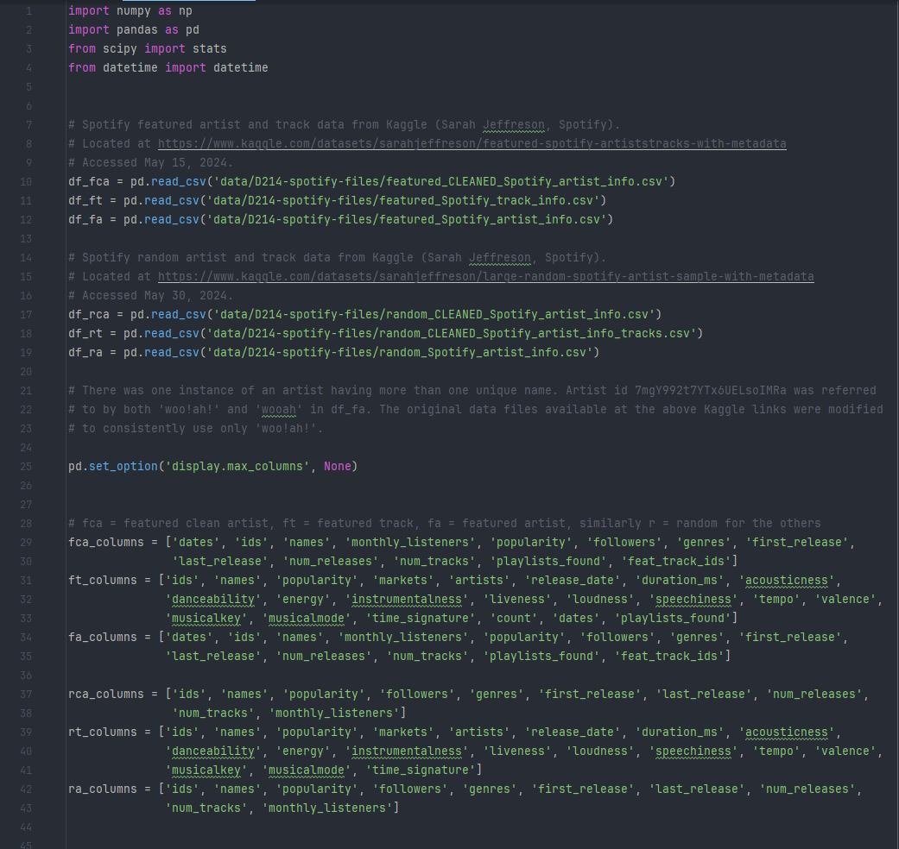

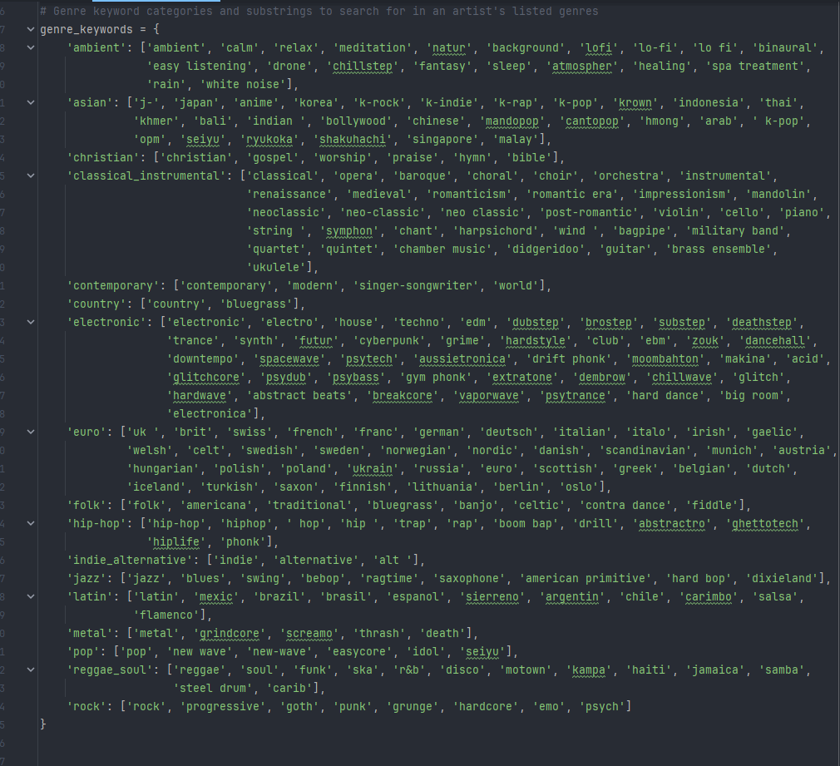

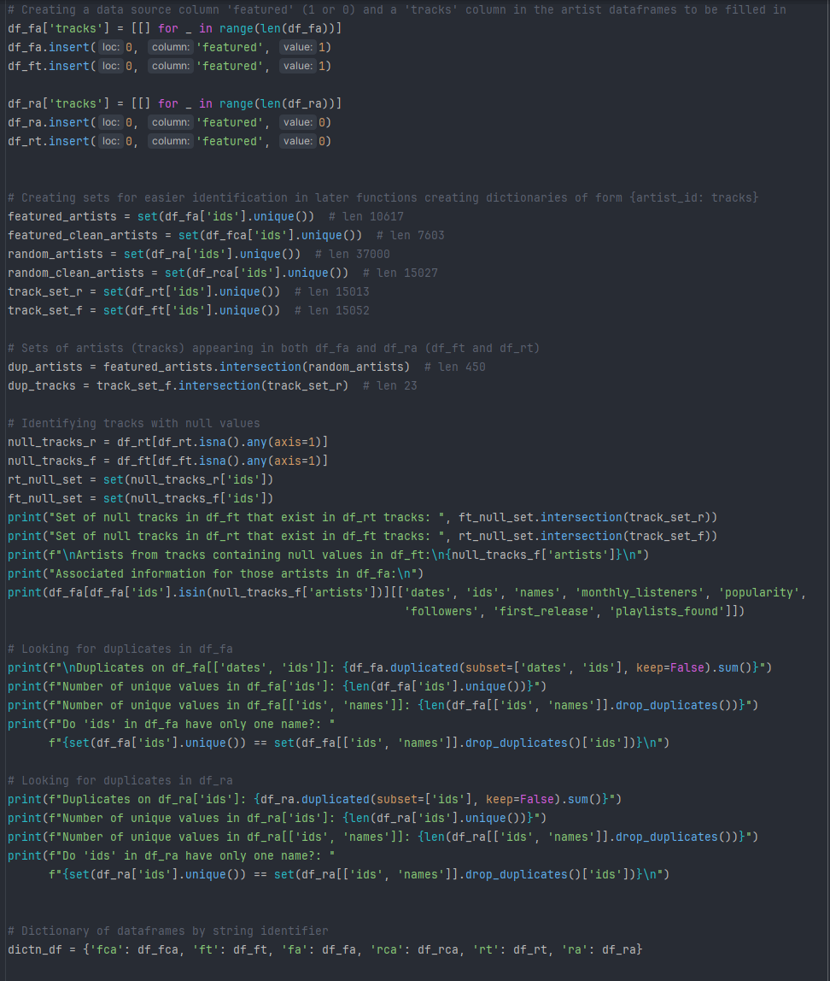

Sets of tracks with null values were created to ensure they weren’t added to an artist’s list of tracks. The featured and random artists dataframes are verified to have no duplicate entries and only one unique name per id. A dictionary of dataframes is created for convenience.

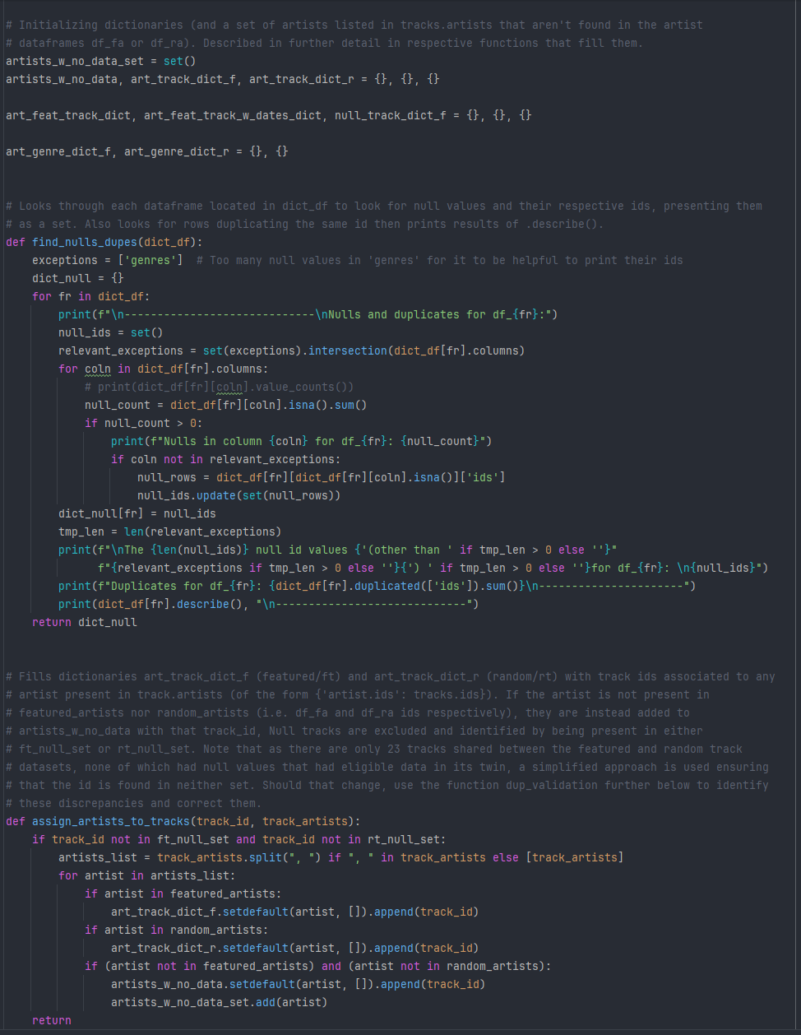

The find_nulls_dupes function provides information on any present null or duplicate values, which are handled later during aggregation. Dictionaries are initialized before being filled with valid tracks and genres belonging to each artist (see the comments in the screenshots above and below).

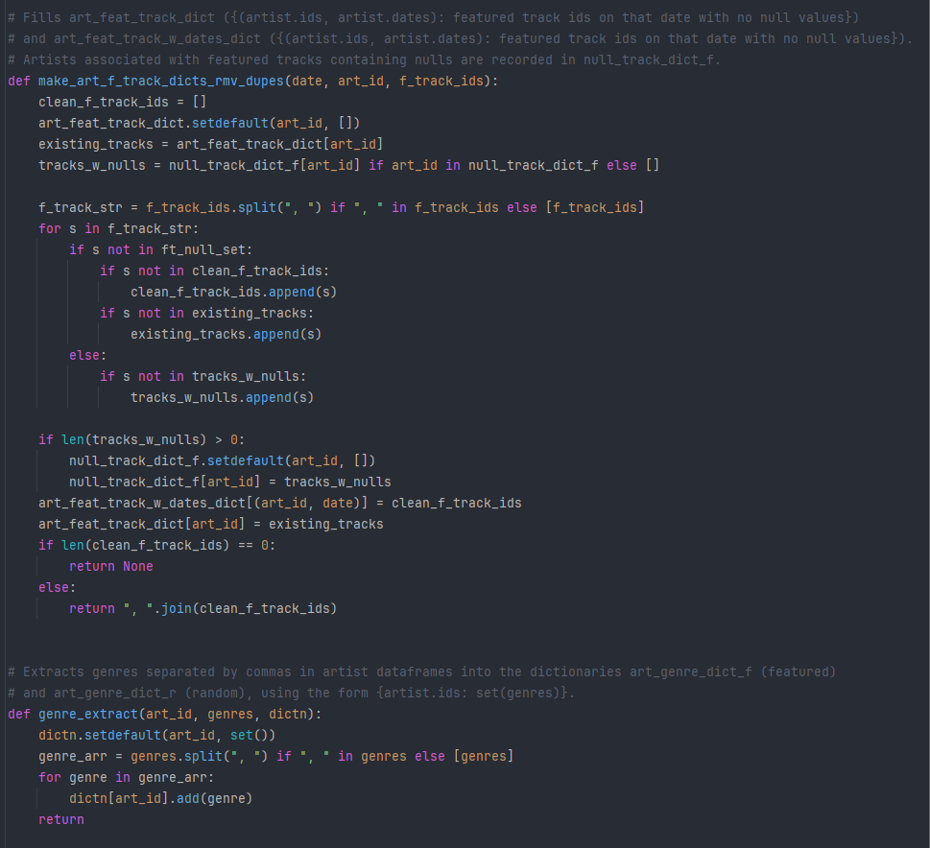

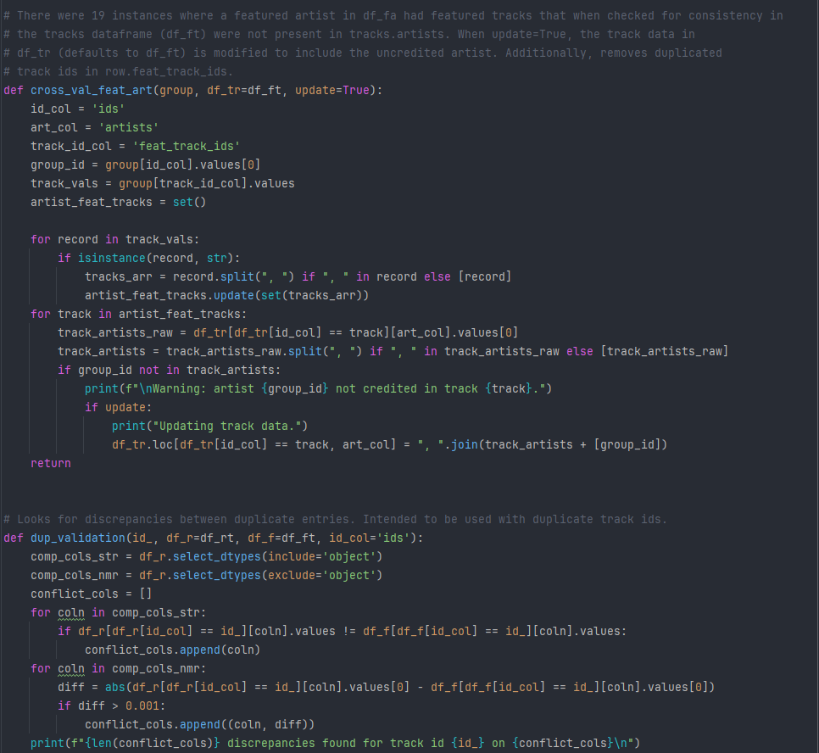

There were 19 cases of an artist in the featured artist dataframe having certain track ids listed in the column ‘feat_track_ids’ where they weren’t appropriately credited in the associated entry for that track in the featured tracks dataframe. As this created problems with finding an associated track for the artist to be joined to, the track entries were updated to include all artists involved. The dup_validation function was an expedient way to reveal that the only notable differences in tracks shared between the featured and random track dataframes were small differences in their popularities. During aggregation, these conflicts were resolved by taking the popularity present in the featured dataframe to remain consistent.

The function genre_filter scans a string of genres using the genre_keywords dictionary to return an array of genre categories present for the artist.

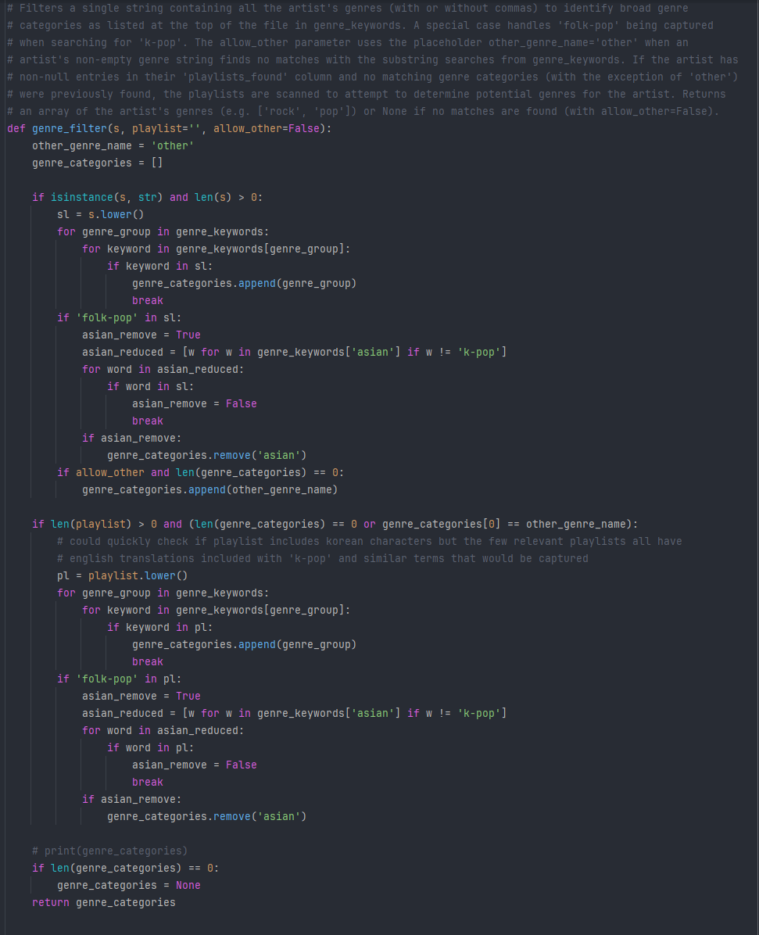

The aggregation function, in addition to the screenshot’s comments, will be described further below.

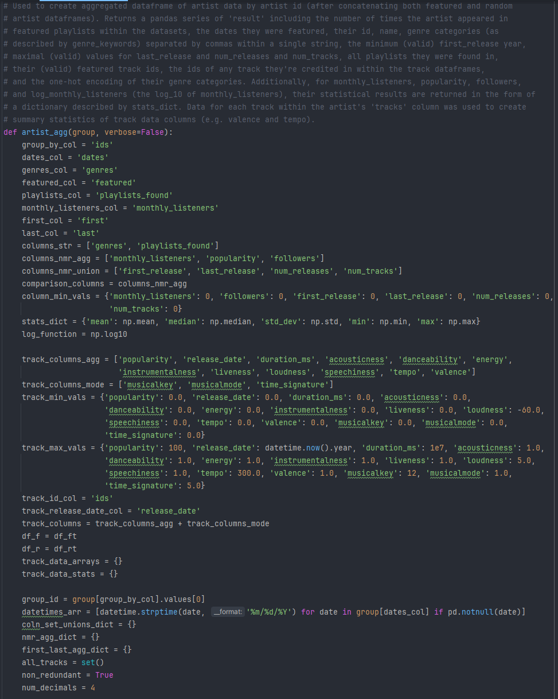

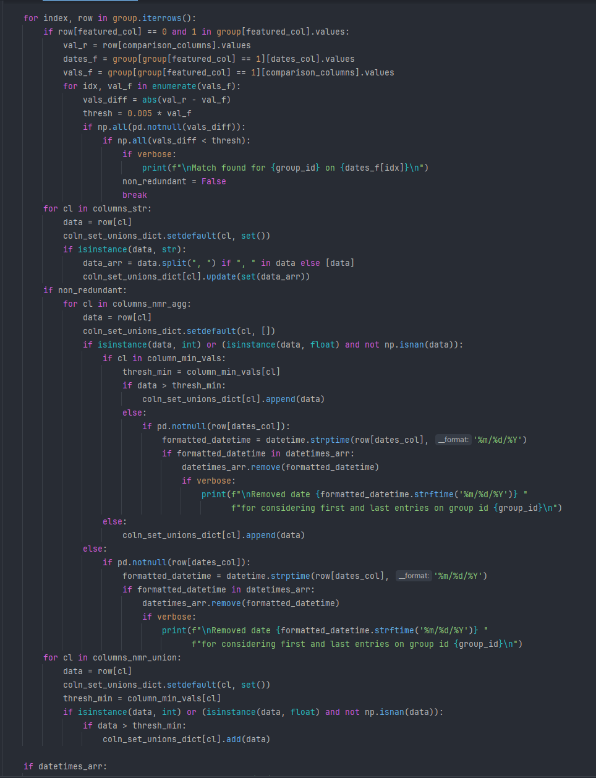

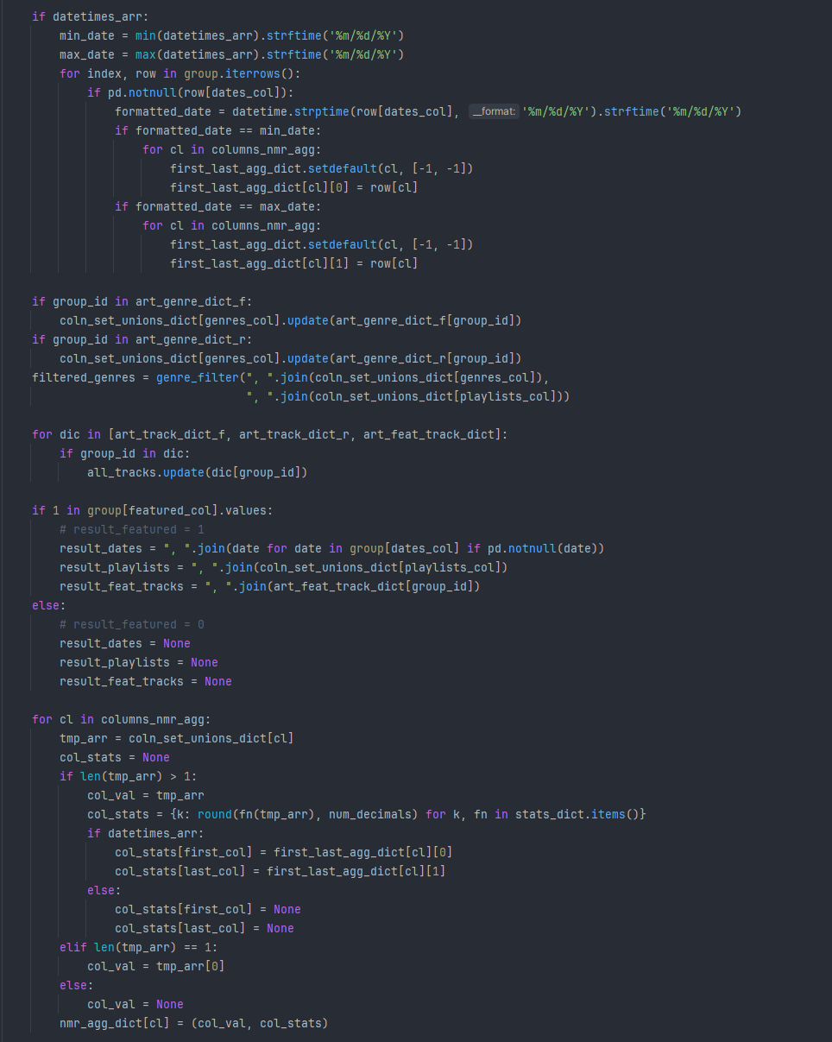

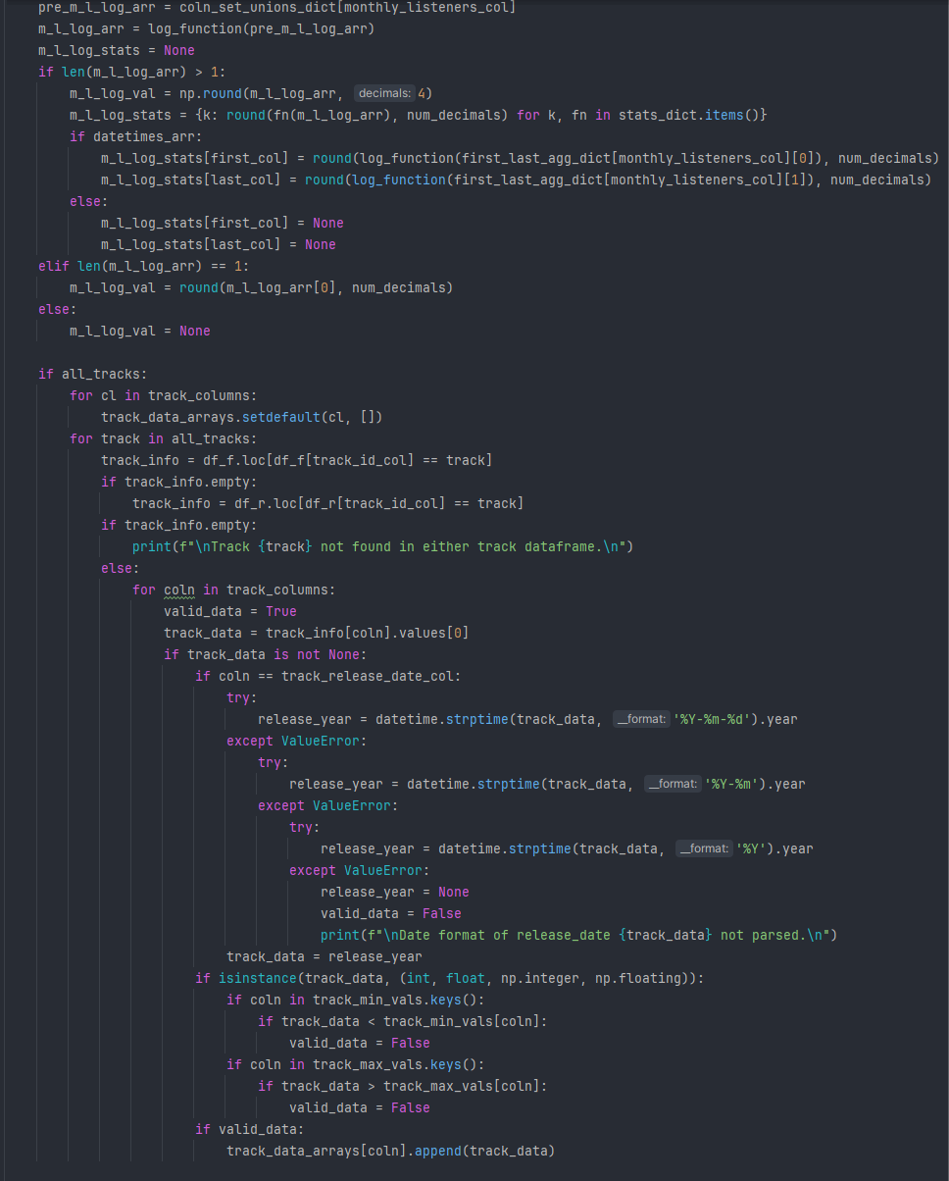

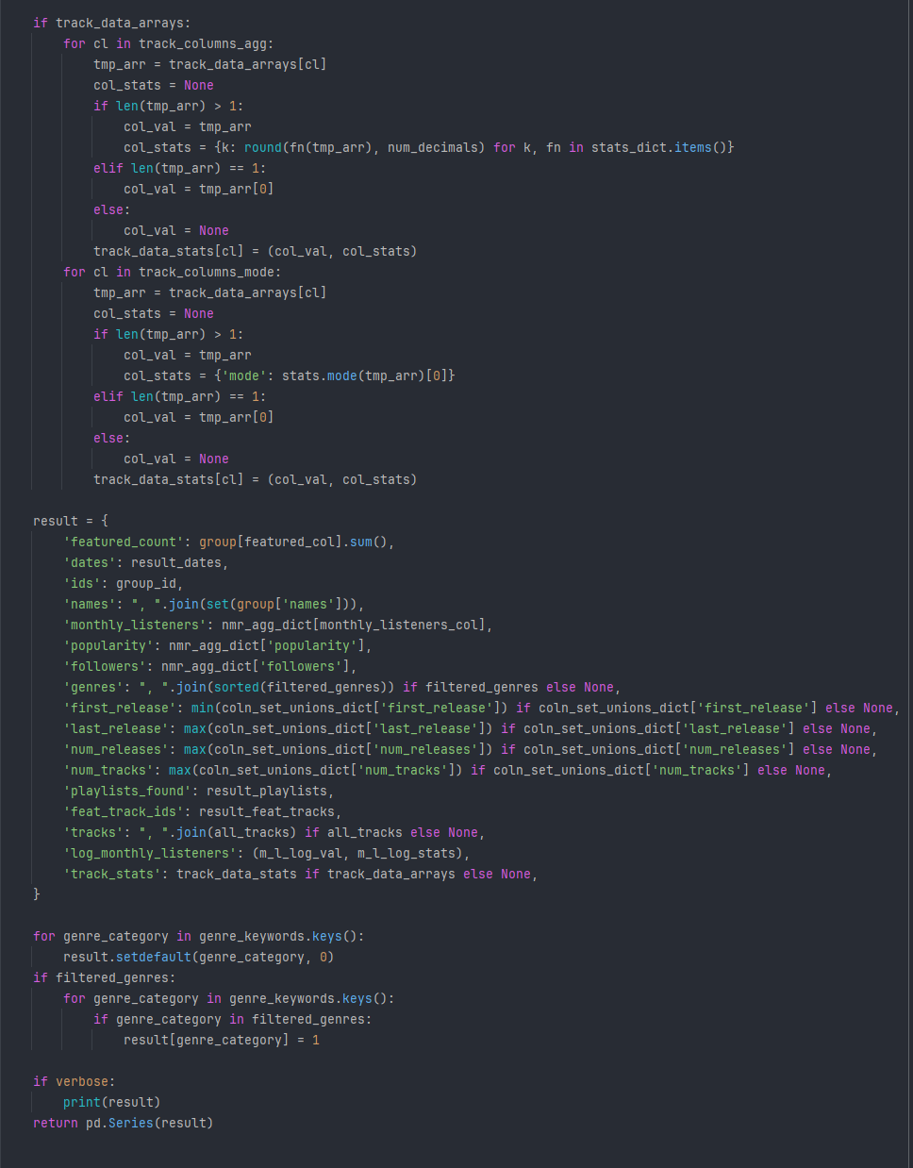

The aggregation function artist_agg is used to create the desired concatenation of the featured and random artist metadata dataframes (‘df_fa’ and ‘df_ra’). It iterates through the rows associated with each group (where both ‘df_fa’ and ‘df_ra’ have been merged using pd.concat) and first handles potential instances of groups with an artist’s id existing in both the featured and random datasets.

Although the random artist data didn’t include the dates they were collected, in several cases the values were so close to one of the entries in the featured data that it amounted to duplication. When an approximate match was found, the row from the random artist metadata within that group was labeled redundant and discarded from numerical aggregation in monthly listeners, popularity, and followers.

The artist’s genres and playlists were concatenated as strings. After verifying the aggregated numerical data (i.e. followers, popularity, and monthly listeners) satisfied any threshold constraints (such as being above 0 and non-null), they were added to an array of values for that group to then be stored in a temporary dictionary. An array of datetimes, datetime_arr, was maintained to record the first and last dates an artist had valid (non-null) entries. The year of an artist’s first release, the year of their last release, the number of their releases, and the number of their tracks was generally consistent throughout. It was unclear if the occasional inconsistencies were due to input error, database updates adding more tracks, or a system bug. These instances were handled by placing all valid (non-null and above any minimum thresholds) data for those columns into sets.

After iterating through all of the rows, the first and last valid dates are determined and used to extract the corresponding entries to be placed into a temporary dictionary.

The dictionaries of all genres attached to an artist (previously handled by genre_extract) are added to a temporary set of genres for the group id, which are then passed to genre_filter to provide an array of the artist’s genre categories as specified by genre_keywords.

Similarly, the artist’s track ids from the dictionaries previously created are added to a set of tracks for the artist.

The arrays of the artist’s (group’s) popularity, followers, and monthly listeners are then handled by several statistics functions including mean, median, standard deviation, minimum, and maximum, with the ‘first’ and ‘last’ values being handled separately. When an array of any of these columns has only one or no elements, the statistical calculations are skipped. The scale of the monthly listeners ranged from 0 to ~108, so the base 10 logarithm value was also calculated and had the same statistical operations performed.

For each of the track ids associated with the artist, the track metadata (such as valence and loudness) was extracted and added to an array (if it was non-null and within the thresholds set) in an analogous procedure to the above with popularity, followers, and monthly listeners. These arrays then received the same statistical operations, with the exception of ‘musicalkey’, ‘musicalmode’, and ‘time_signature’, where it was more appropriate to take the mode. Although these columns are numerical, they are better viewed as categorical data.

Finally, the aggregated and calculated values are presented as a dictionary ‘result’. The new column ‘featured_count’ counts the number of times an artist was featured. The monthly listeners, popularity, and followers columns are presented compactly as tuples of a value and a dictionary (to be handled later). The generally consistent integer columns ‘first_release’, ‘last_release’, ‘num_releases’, and ‘num_tracks’ took the minimum value of ‘first_release’ and the maximum values within each of the other three variables. It’s not clear why the discrepancies existed in the first place, but the errors appeared to be occasional missing data and probable incorrect data entry, so taking the extremal values was appropriate and had no instances of erroneous outliers (which were safeguarded against by imposing thresholds). The ‘tracks’ and ‘genres’ columns are returned as concatenated strings. The ‘log_monthly_listeners’ column is a tuple of a value and a statistics dictionary comparable to the presentation of ‘monthly_listeners’. The added ‘track_stats’ column contains nested dictionaries for each of the track metadata variables. Afterward, the genre categories for each artist are one-hot encoded and added to the ‘result’ dictionary, which is then returned as a pandas series.

Supplementary functions expand_stat_dict and fill_nulls were introduced for more convenient and efficient analysis at a small increase in file size. When a variable had a singular value, the null standard deviation was filled with 0 and the other statistical columns (such as ‘_median’ and ‘_mean’) were assigned the singular value for that variable. The added “val” columns were intended to be a quick reference to relevant numerical data among all variables of interest, including the numerical yet not technically ordinal variables such as musical key where the mode was used. By default, the expand_stat_dict function assigns the median as the representative value for any relevant numerical column with statistical calculations.

The functions generate_raw_agg_df and clean_raw_agg_df were used to run the aggregate function artist_agg, save the new dataframes to a csv files, remove rows with null values in critical columns (i.e. null values in ‘dates’ and ‘feat_track_ids’ are expected for artists that only resided in the random sampling and are acceptable), recast what should be integer columns from floats back to integer values, then unpack the compressed and unwieldy statistical dictionaries into separate columns.

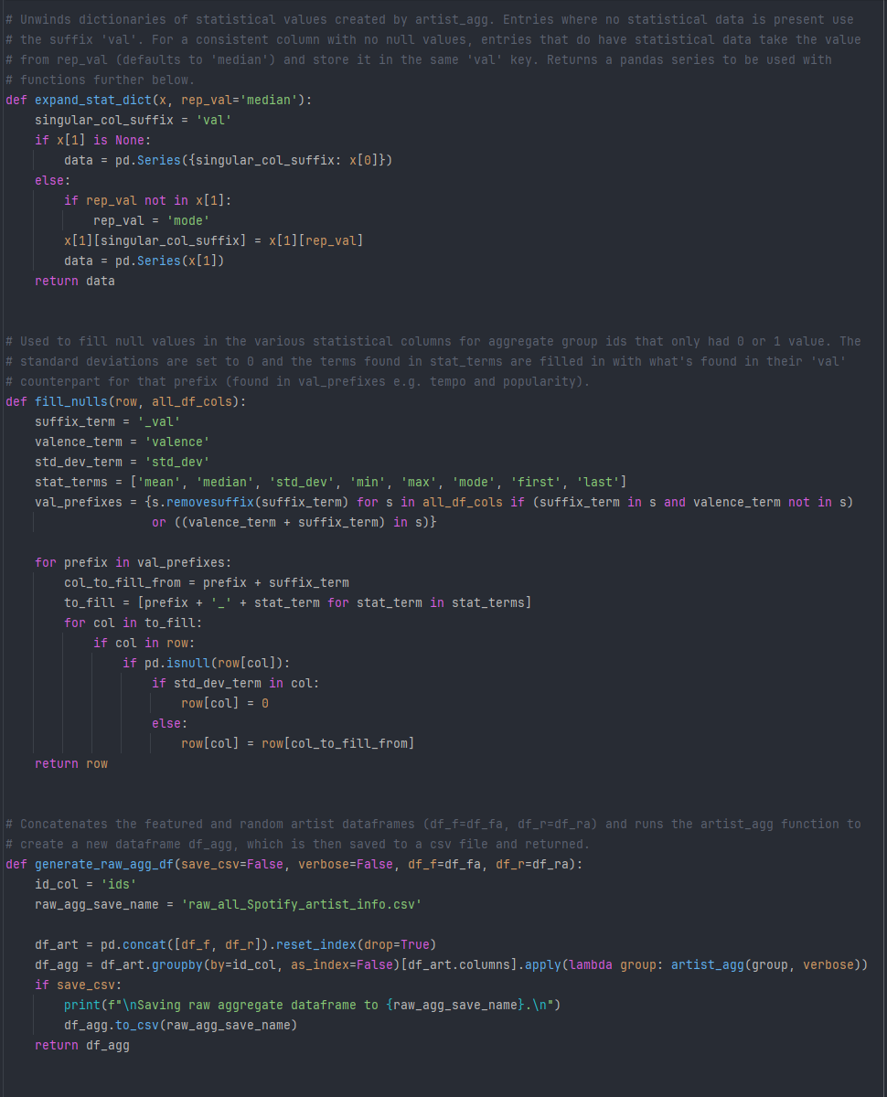

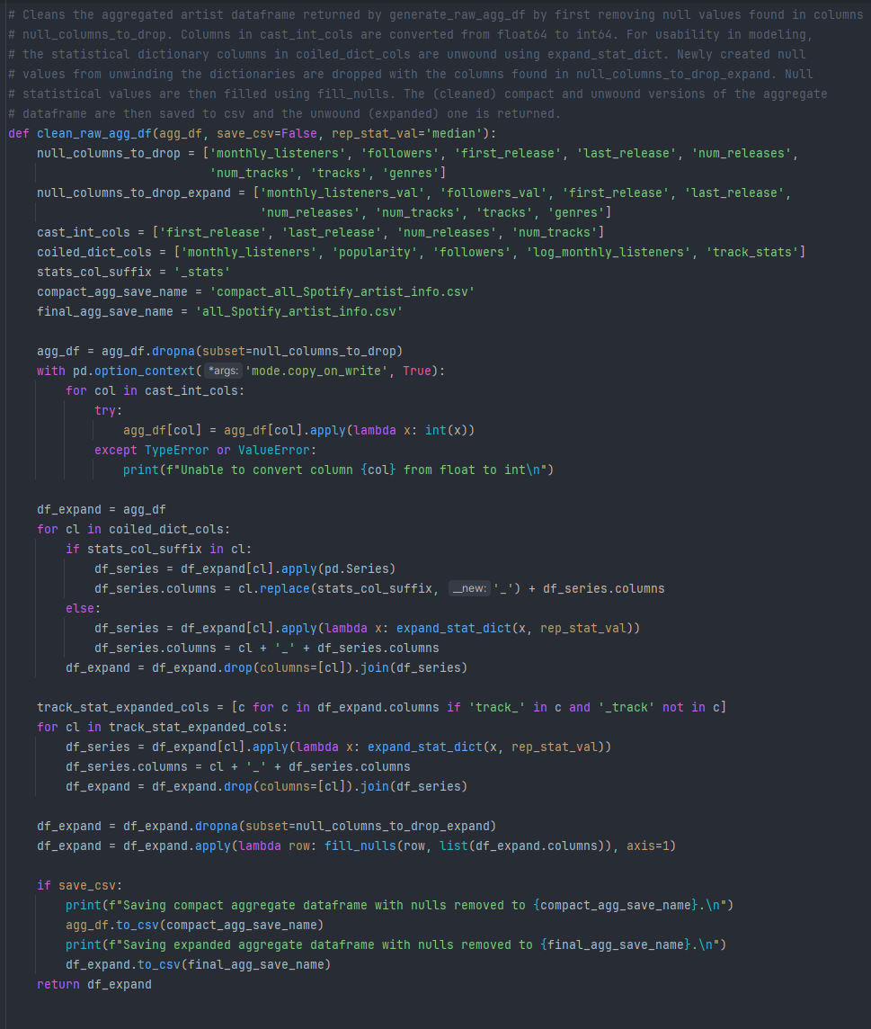

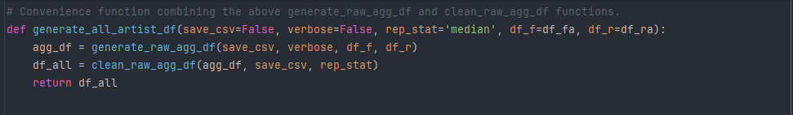

Creating the aggregated track dataframe follows a simplified version of the procedure for the aggregated artist dataframe. Of the 23 tracks that existed in both the featured and random datasets, the featured values were favored. As previously mentioned, the only inconsistencies were small differences in popularity, most likely due to the days the data was collected. In contrast to taking aggregate statistics values across all of an artist’s available songs within the datasets, the aggregated track dataframe took the first artist in its ‘artists’ column that could be found within the aggregated artist dataframe. This prioritized the primary artist (or in some cases “co-primary”) for the track as the artist ids separated by commas within the track’s ‘artists’ string are listed left to right in order of relevance, including cases of equal partnerships and collaborations. While this may not be fully representative for all tracks with more than one artist, it’s a compromise to avoid reducing the validity of other tracks with multiple contributing artists (in a handful of cases it went above 20 listed artists) who didn’t necessarily contribute in similar measures, which itself is impossible to estimate without manual inspection. Additionally, more popular artists making a minor appearance in a track for a less popular artist would not necessarily be representative of the primary audience for that track, as well as distorting the artist genres associated to that track if multiple artists have widely varying genres but happen to coalesce on the particular track they mutually participated in.

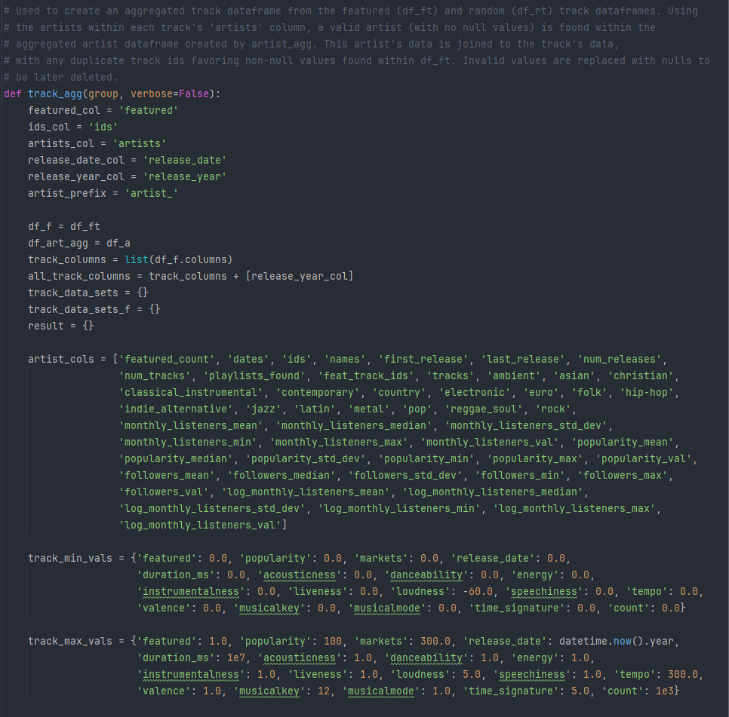

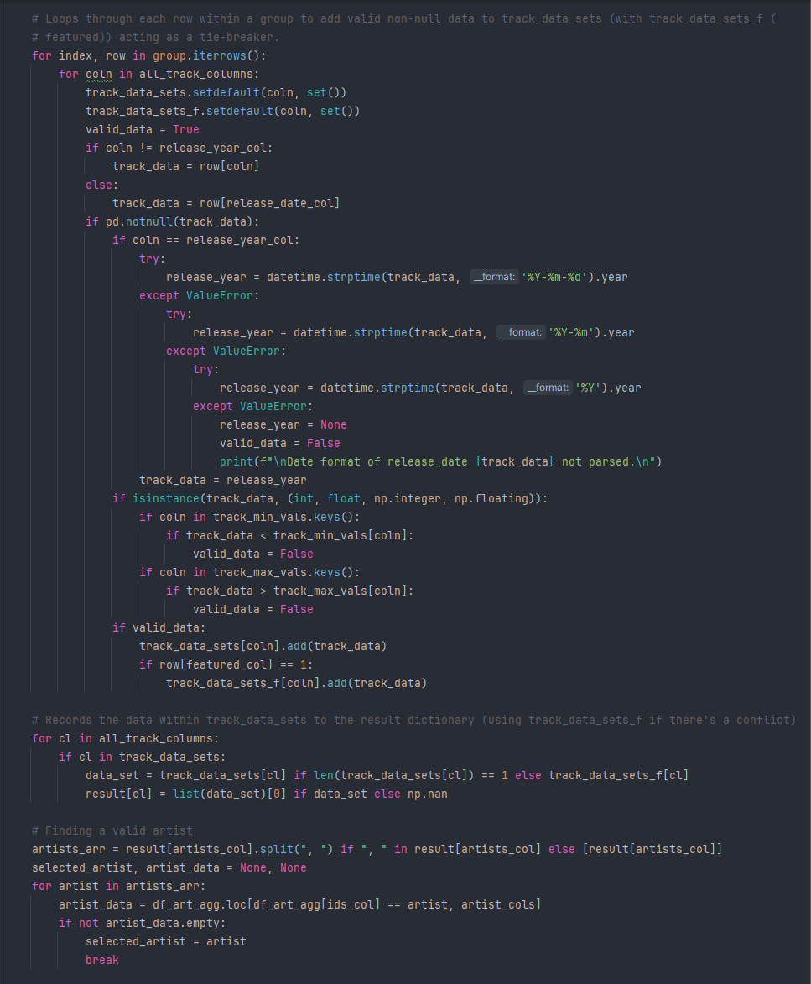

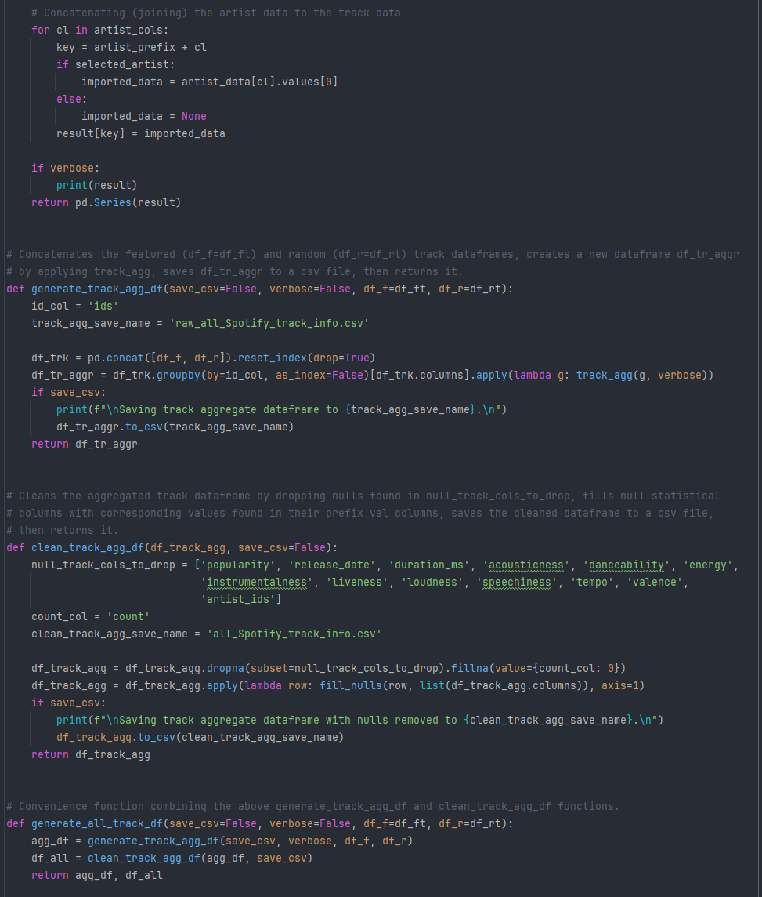

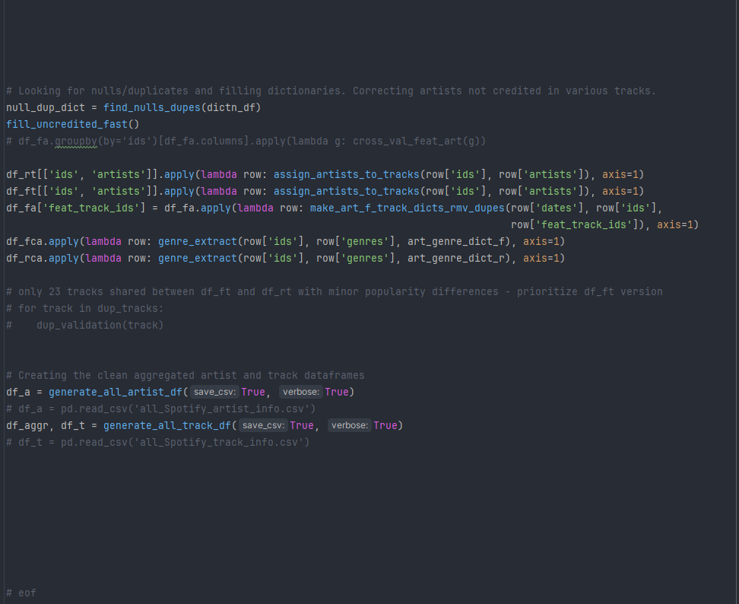

The generate_track_agg_df and clean_track_agg_df functions perform analogously to their artist_agg counterparts.

Finally, the functions are run and the aggregated dataframes are created to be used in the random forest modeling.

**D. Analysis**

The data analysis is best viewed in the attached file “capstone.py”.

The extensive statistical values were calculated and retained during processing to inspect their relevance to the models, rather than simply selecting the median or mean and potentially losing valuable information, given the extensive differences in scales between little known and incredibly popular artists. The logarithm of the monthly listeners was included to handle the distribution’s skewness and broad scale.

While this may produce some degree of redundancy and multicollinearity in modeling, and required an involved handling of compact dictionaries during processing, the robustness of the random forests benefited from the inclusion of multiple statistical values for the same variable, producing superior models than those that were restricted to only mean or median values.

Random forest regressors use an ensemble of decision trees to predict a numerical target by taking the mean of the trees’ predictions. Each decision tree divides the data into sequentially smaller subsets through conditions over a random subset of the features at each node. The value of a terminal leaf node (having traced the tree with an input data point) is the predicted value for that input.

Utilizing multiple decision trees in a random forest regressor model to account for the vast complexity in what creates a popular song or artist is a preferred strategy for optimal predictive capabilities.

Averaging over multiple estimators has the advantage of reducing overfitting and the impact of outliers (Elleh, 2023 [7]). As powerful as random forests are, they offer limited intuitive and practical insight into the model’s internal functioning. Feature importance scores and other information can be extracted, but lack the concreteness of a linear regression model’s coefficients giving a clear depiction of the impact of each variable changing by given quantities. Further, heavily skewed distributions and imbalanced classes may lead to important data points never being seen by many of the trees.

The mean squared error (MSE) is the mean of the squares of the differences between the observed and predicted values, defined as:

$$MSE=\frac{1}{N}\sum_{i=1}^{N}{{\left(y_{i}-{\hat{y}}_{i}\right)}^{2}}$$

The square root of this quantity is the root mean squared error (RMSE). The mean absolute error is the mean of the absolute value of the error terms, given by:

$$MAE=\frac{1}{N}\sum_{i=1}^{N}{\left|y_{i}-{\hat{y}}_{i}\right|}$$

The coefficient of determination, $R^{2}$, is given by

$$R^{2}=1- \frac{\sum_{i=1}^{N}{{\left(y_{i}-{\hat{y}}_{i}\right)}^{2}}}{\sum_{i=1}^{N}{{\left(y_{i}-\overline{y}\right)}^{2}}}$$

All of these quantities will be used to evaluate the statistical significance of the models, with minimizing the MSE (and its square root RMSE) the target of optimization. Root mean squared error will be used to evaluate the performance of the model, keeping in mind the different scales on the two target variables (popularity ranges from 0 to 100 while monthly listeners range from 0 to ~108).

Regression models do not have a clear and definitive accuracy metric, so rely on minimizing the error. RMSE has increased penalties for profoundly incorrect predictions compared to MAE. A model’s reliability and utility has poor tolerance for large errors in most circumstances, thus minimizing MSE (and RMSE) provides the most effective models. It has the advantage of being easily calculated as the square root of scikit-learn’s mean_squared_error function but the disadvantage of not representing an intuitive idea of “average dispersion” (which would be better measured by MAE), as it’s the square root of the mean of the squares of the error terms.

Recursive feature elimination recursively removes the least relevant feature from the model until hitting a prescribed threshold or halting point. They benefit models by removing irrelevant (or at least less important) predictor variables to simplify the model. In some cases the simpler model actually performs better, along with being easier to implement and manage in the future.

The imperfect implementation of recursive feature elimination used in this project cannot guarantee a globally optimal solution without a costly and extensive search process, as removing the worst performing feature on one iteration may under certain circumstances be of benefit to include later. There are slight alterations to the worst performing feature at each iteration given the initial set of features provided, which can produce small differences in final models. However, the differences are generally quite marginal, so although the theoretical optimum isn’t known with certainty, the sets of features produced by recursive feature elimination perform very well and indicate the global optimum isn’t considerably better.

Hyperparametric tuning searches for model parameters, such as the number of decision trees used and the maximum tree depth, that minimize the MSE (or similar statistical target). Although reasonable parameters can be determined by a given dataset or domain knowledge, it’s not always intuitive nor is it necessarily a simple trade-off between time and model performance. Parametric grid searches ensure the best model is selected from the provided candidate values. It has the advantage of clarifying any incorrect assumptions on ideal model parameters but has the disadvantage of potentially being quite time-consuming.

For reference, a seaborn pair plot is provided below (primarily of median values) but requires a zoom feature for legible labels. It’s also attached as a separate file “artist_pairplot.png”.

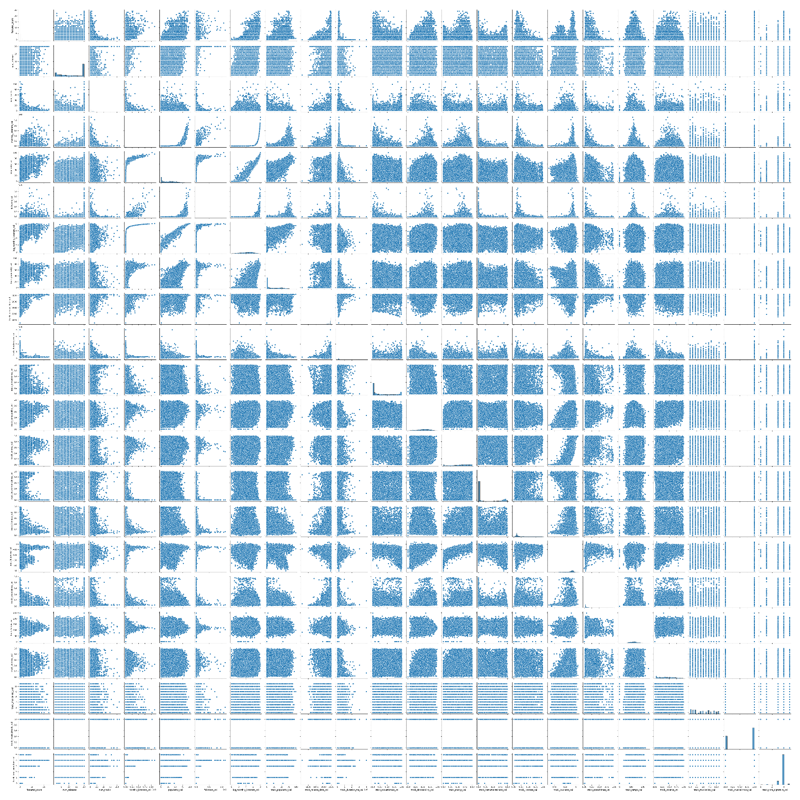

Dataframes are loaded as “df_a” for the aggregate artist dataset and “df_t” for the aggregate track dataset, with an additional ‘range’ column being added that’s calculated as the difference between the maximum and minimum values. The variables for each of the dataframes are listed, along with defining useful subsets such as mean values and maximum values. The variables are inherited from the variables present in the original datasets (as described in section B.), with additional variables for:

* ‘_mean’: mean
* ‘_median’: median
* ‘_std_dev’: standard deviation
* ‘_min’: minimum
* ‘_max’: maximum
* ‘_first’: value on the earliest date the artist was featured within the data (if applicable)
* ‘_last’: value on the last date the artist was featured within the data (if applicable)
* ‘_val’: set to median (or the singular value) during processing, using mode for the non-internal numeric data
* ‘_mode’: mode for musical key, time signature, and musical mode (non-interval numeric data)
* ‘_range’: maximum minus minimum value

The genre columns are one-hot encoded as previously discussed and are as follows:

* 'ambient'
* 'asian'
* 'christian'
* 'classical_instrumental'
* 'contemporary'
* 'country'
* 'electronic'
* 'euro'
* 'folk'
* 'hip-hop'
* 'indie_alternative'
* 'jazz'
* 'latin'
* 'metal'
* 'pop'
* 'reggae_soul'
* 'rock'

The variables in “df_a” with a “track_” prefix are the aggregated statistical values for that variable across all of the artist’s tracks present in the initial track datasets. Variables beginning with “monthly_listeners_”, “popularity_”, or “followers_” are aggregated from all of the artist’s occurrences in the original artist datasets (with multiple instances of the same artist due to being featured on different dates).

In contrast, the variables in “df_t” with an “artist_” prefix use the aggregated data found within the aggregate artists dataframe “df_a” for the one selected artist (specified by ‘artist_ids’).

The six target variables are specified:

For the aggregate artist dataframe “df_a”:

* ‘popularity _val’: The median of the artist’s popularity across all rows with their id (taking the singular value if they were only present once).
* ‘monthly_listeners_val’: The median of the artist’s monthly listeners across all rows with their id (taking the singular value if they were only present once).
* ‘log_monthly_listeners_val’: The median of the artist’s $\log_{10}('\text{monthly_listeners_val')}$ across all rows with their id (taking the singular value if they were only present once).

For the aggregate track dataframe “df_t”:

* ‘popularity’: The track’s popularity (taking the popularity within the featured track dataset for the 23 tracks present in both featured and random datasets)
* ‘artist_monthly_listeners_val’: The median of the selected (primary) artist’s monthly listeners across all rows with their id (taking the singular value if they were only present once), taken from the data calculated in the aggregate artist dataset.
* ‘artist_log_monthly_listeners_val’: The median of the artist’s $\log_{10}('\text{monthly_listeners_val')}$ across all rows with their id (taking the singular value if they were only present once), taken from the data calculated in the aggregate artist dataset.

Parameter values for parametric grid searches, refined sets of variables for initial modeling and exploration, and sets of variables for recursive feature elimination are also provided.

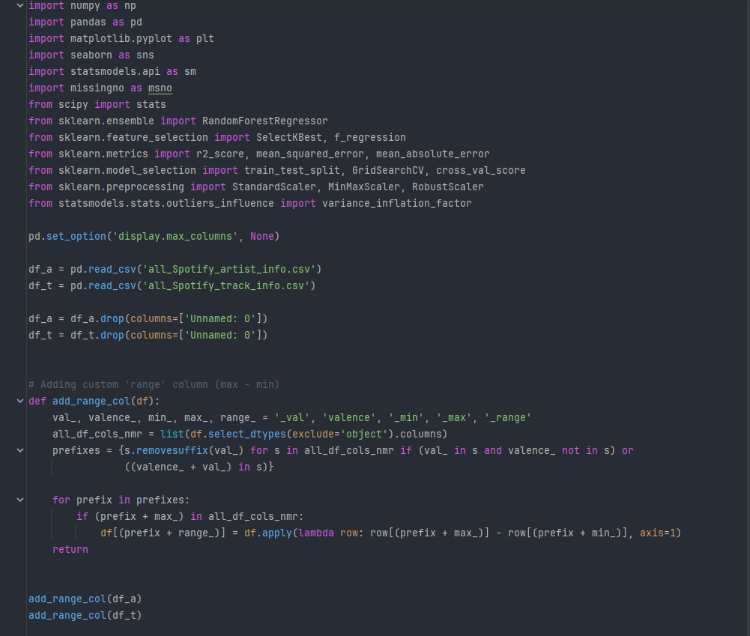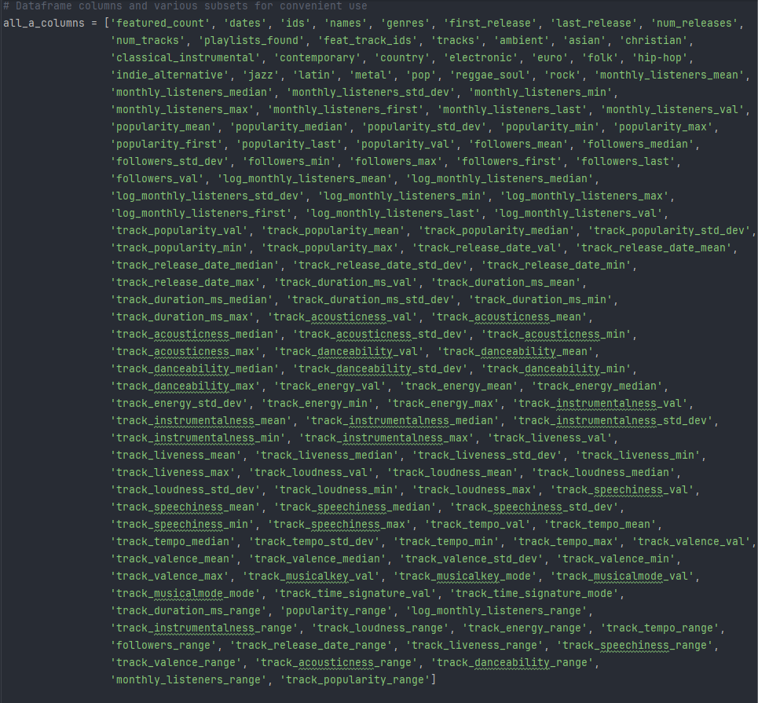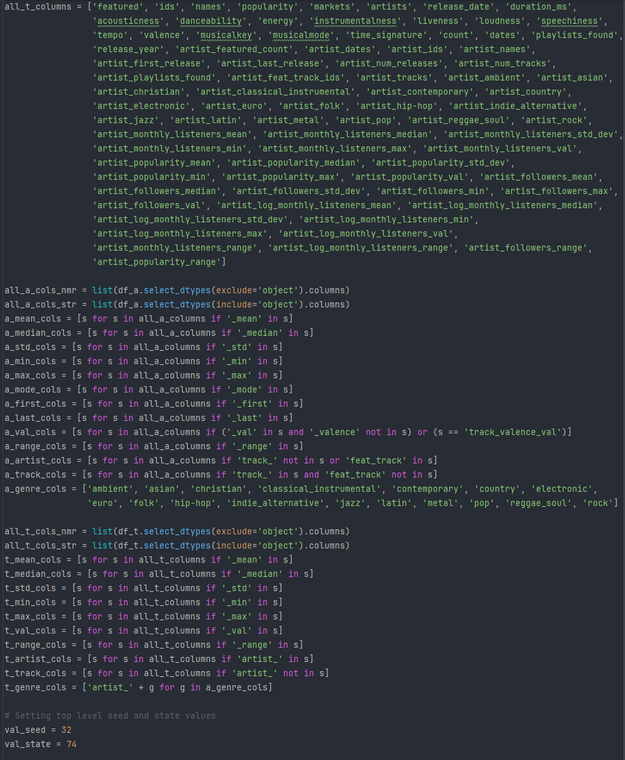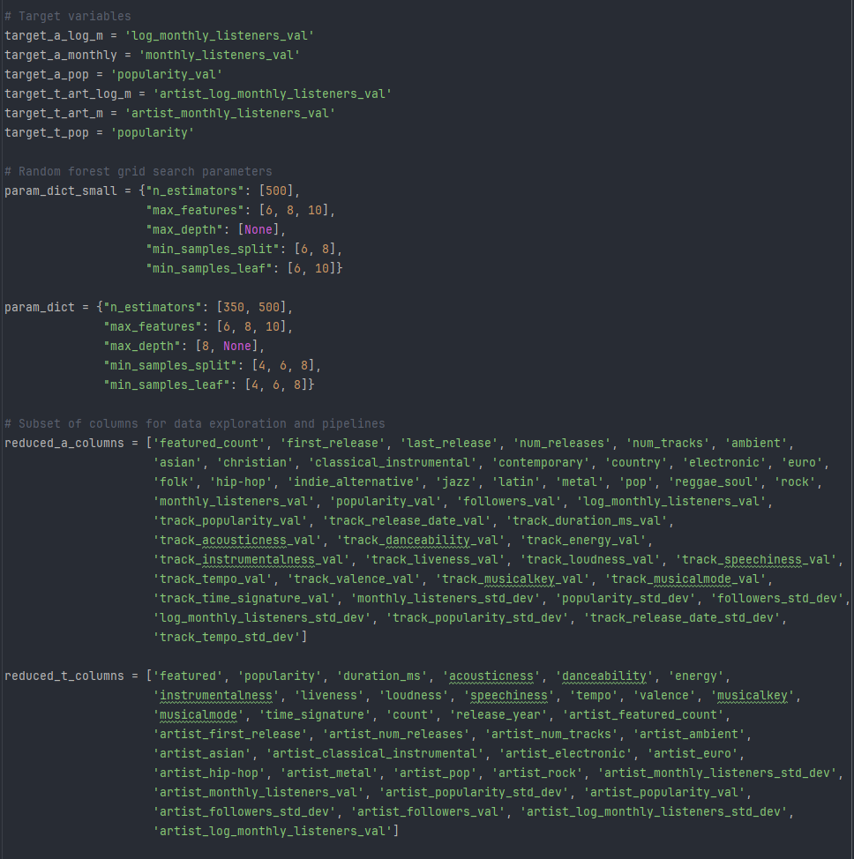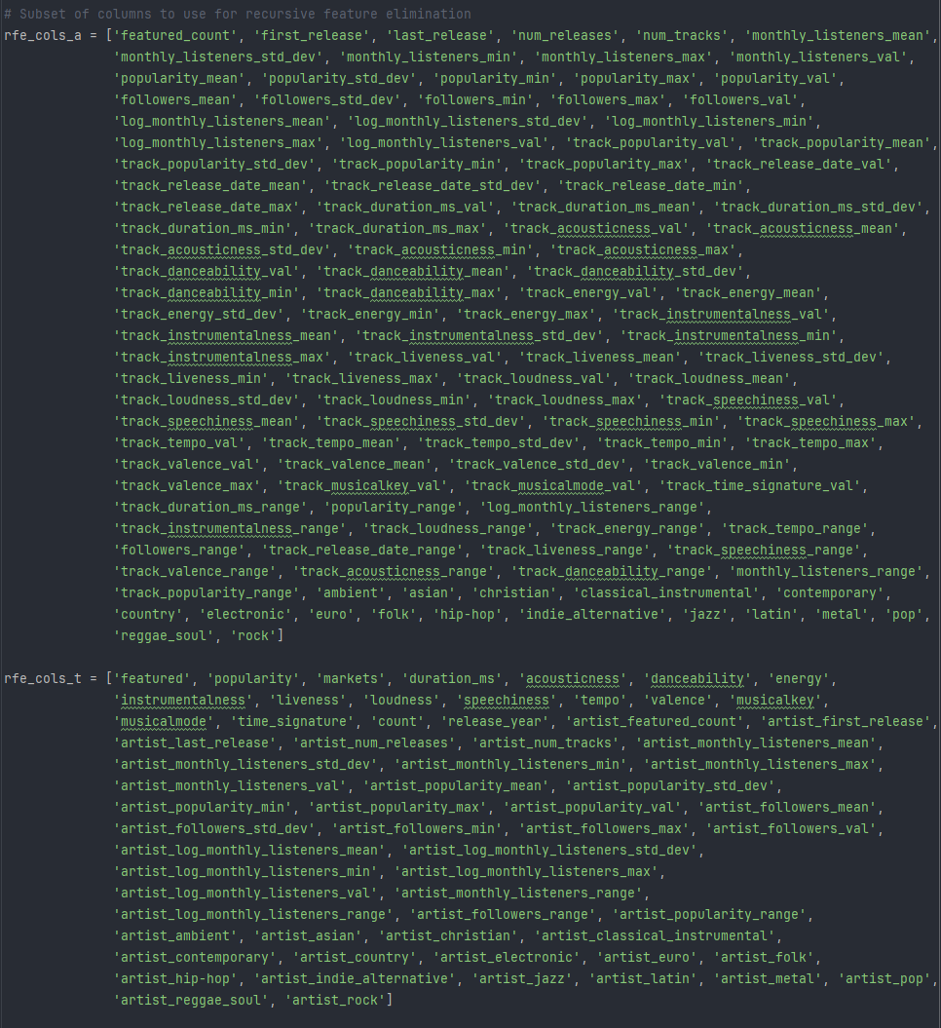

The first five functions below; info_print, inspect_data, plots_by_column, outlier_search, and corr_search; were used for initial data exploration, with some of their output displayed further below as the models were constructed. Of particular relevance is corr_search to determine statistical correlations between each of the six target variables and other variables within the datasets.

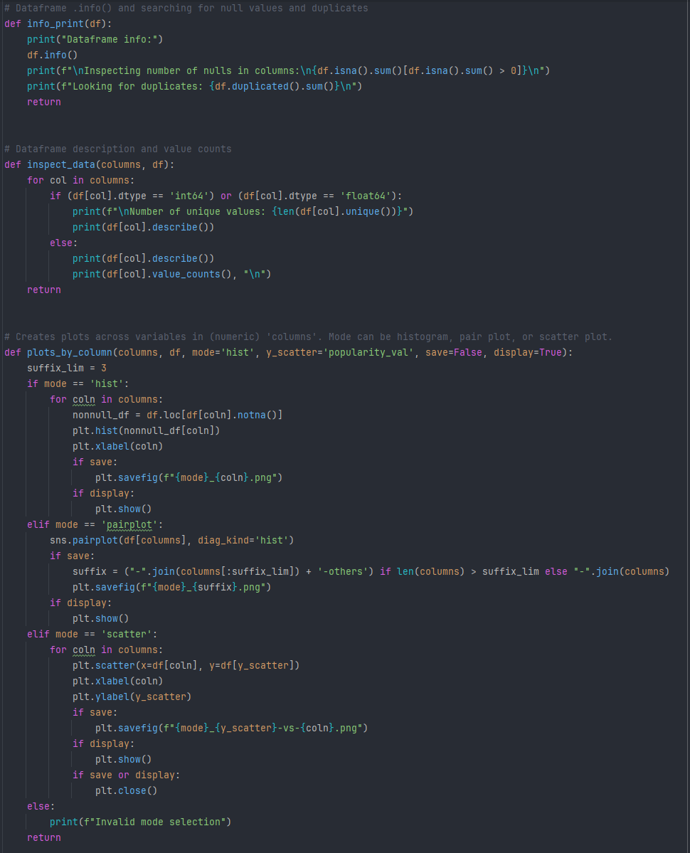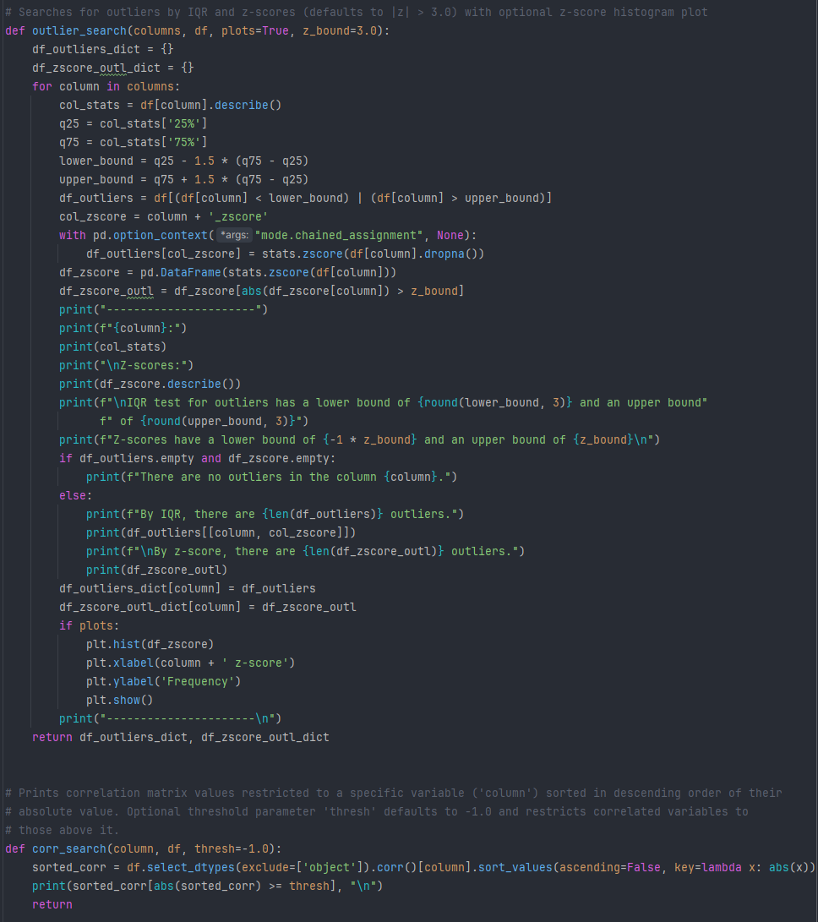

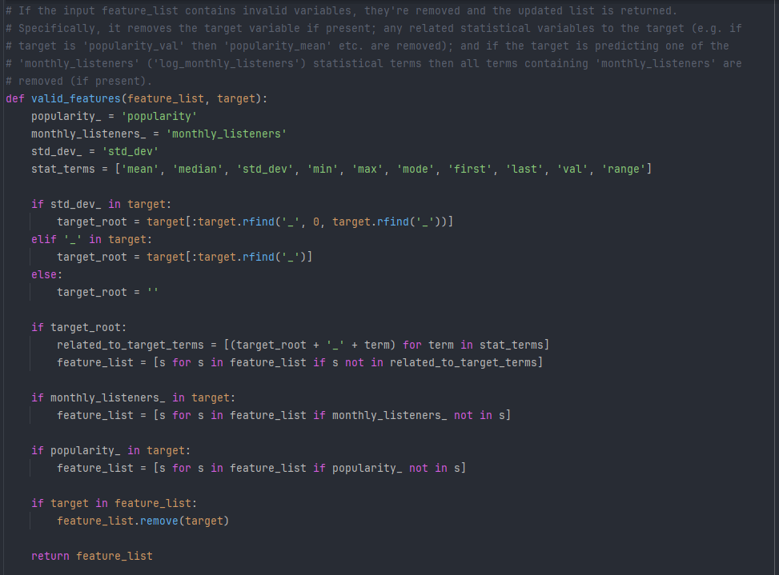

To streamline the specification of features used in a model, valid_features verifies the features used for a target don’t erroneously include the target itself or any sibling statistical value that the model shouldn’t have access to (e.g. inadvertently predicting the median popularity from the mean popularity and other variables would not be a useful model). The function create_y_X_frames is used to automate the creation of dataframes for independent and dependent variables, which are then passed to scale_split to split the data (this project used 80% training and 20% testing).

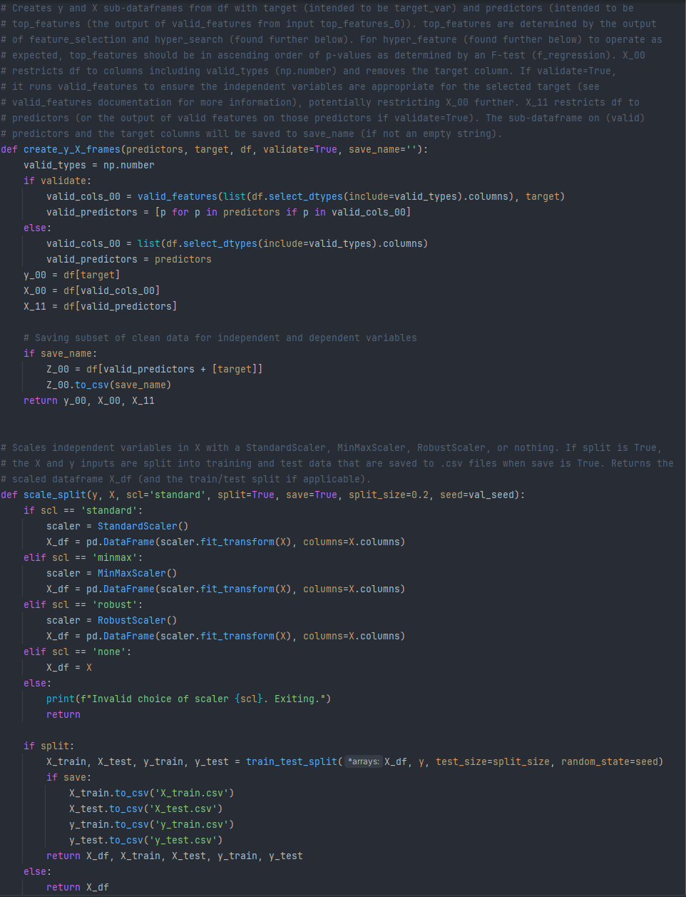

The function feature_selection uses SelectKBest from scikit-learn to display the most relevant features as determined by an F-test, while also using its subsidiary function vif_print to display the variance inflation factors with p-values below a designated α threshold.

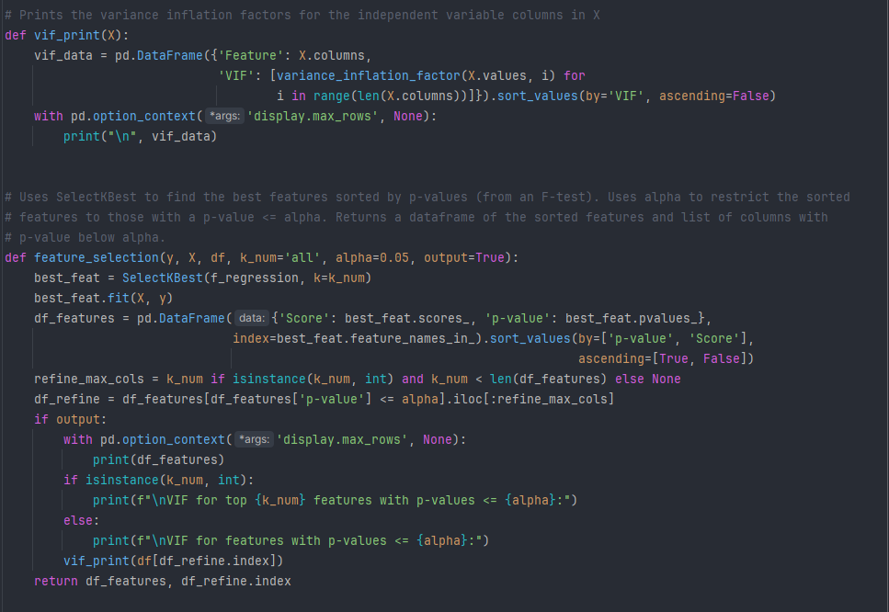

Random forest regressor models are created by predictor_rf on a target y and predictors X, with various parameters for cross validation and displaying QQ and residual plots. It produces summary statistics such as the MSE, RMSE, $R^{2}$, MAE, and feature importance scores.

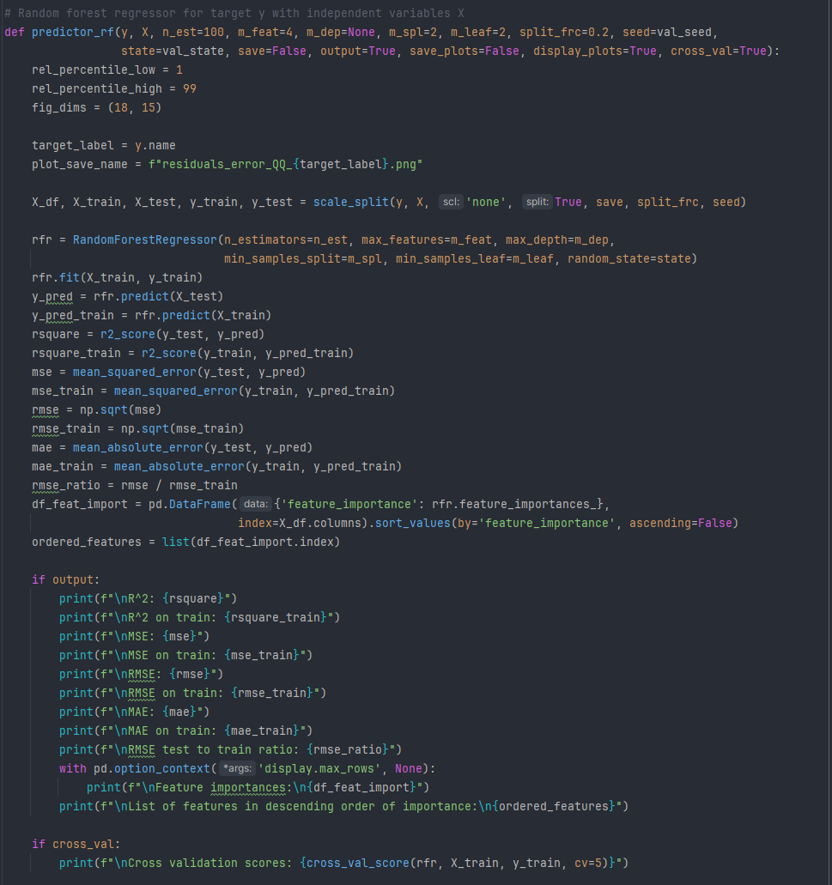

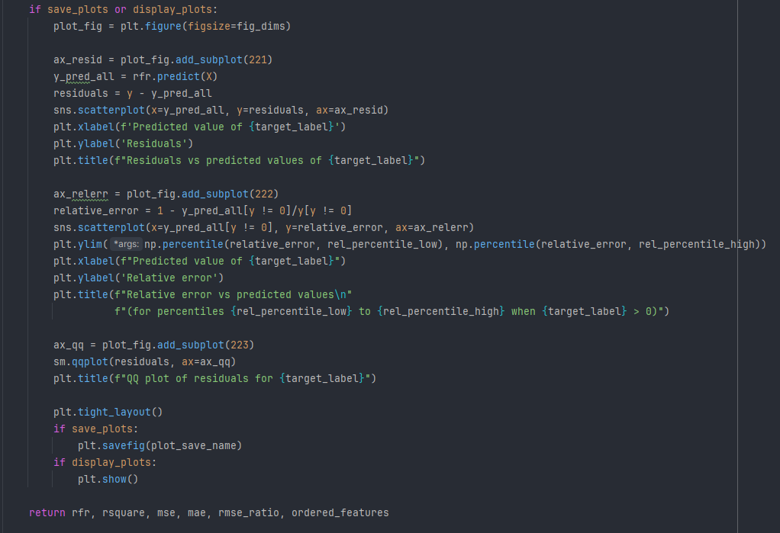

The random forests were optimized through hyper_param below, which performs a parametric grid search to determine the best performing parameters given a target and predictor variables as determined by mean squared error.

An imperfect optimizing function hyper_feature is used to run hyper_param on an incrementally increasing set of predictors in ascending order of their p-values as determined by the F-test performed with feature_selection. It produces the optimal parameters, MSE, and $R^{2}$ for each set of features to determine the best performing (contiguous from index 0) subset of features among those provided. It’s a compromise that can’t guarantee a global optimum in exchange for a semi-reasonable runtime.

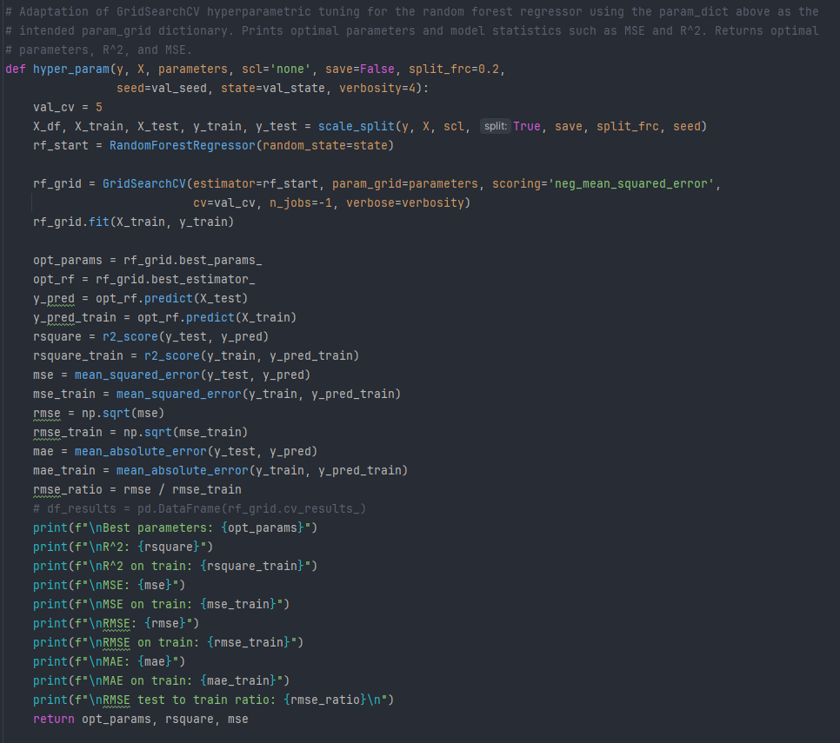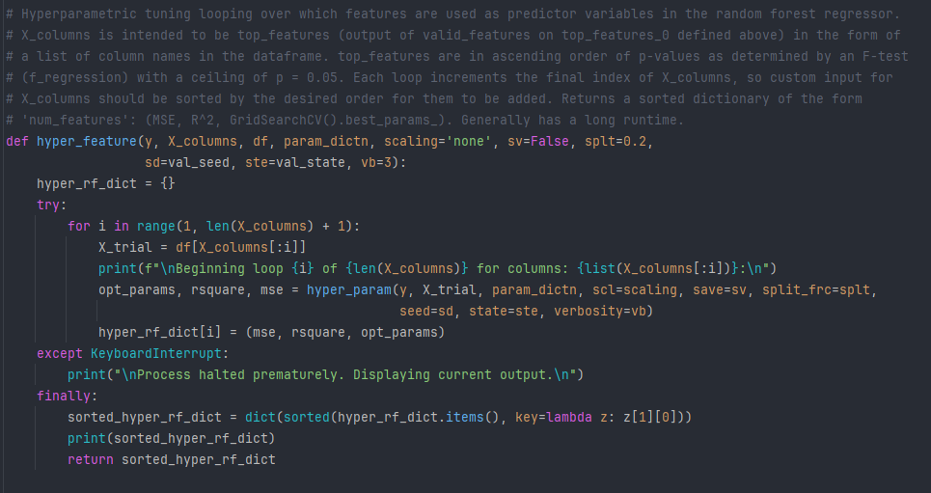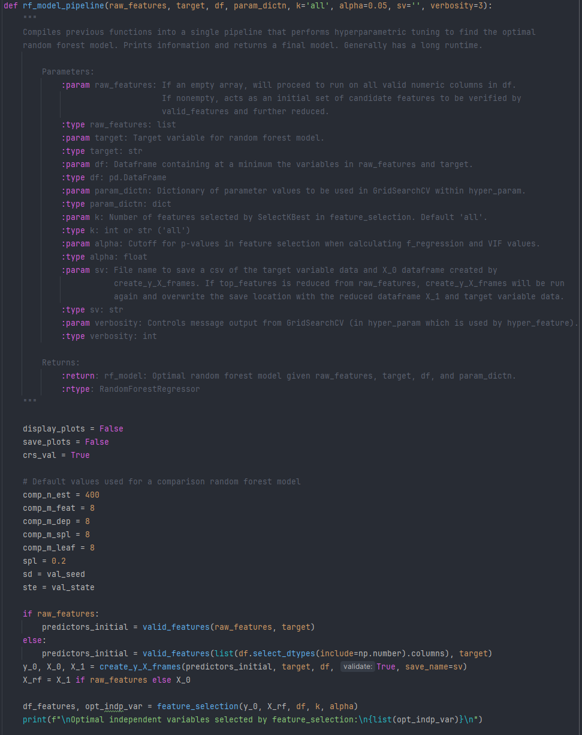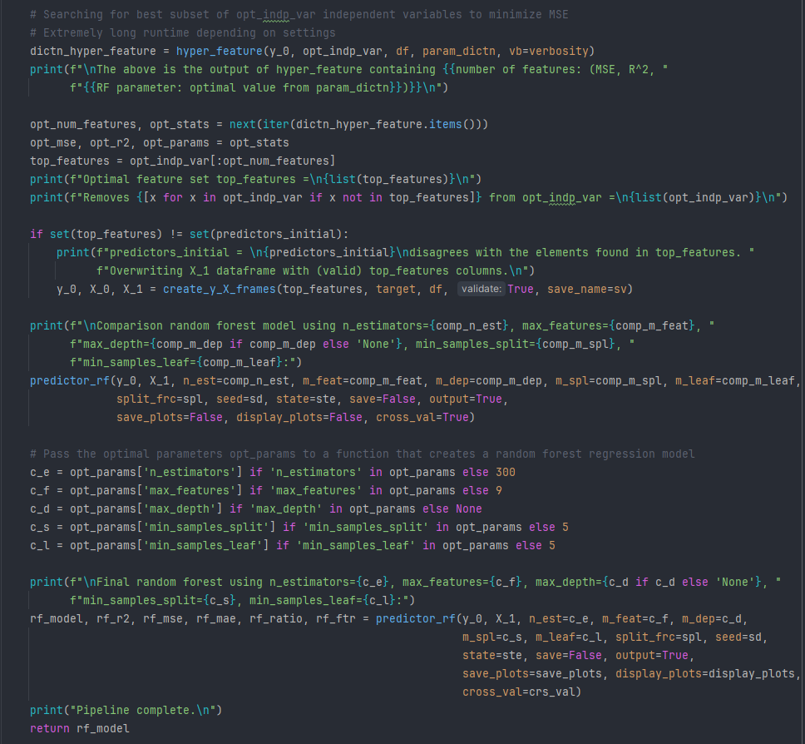

These processes are combined in rf_model_pipeline, which takes an input set of features and a target variable to find the subset of most relevant features, run hyper_feature to refine that further to the best performing features, then produces the best performing random forest model as determined by the parametric grid search.

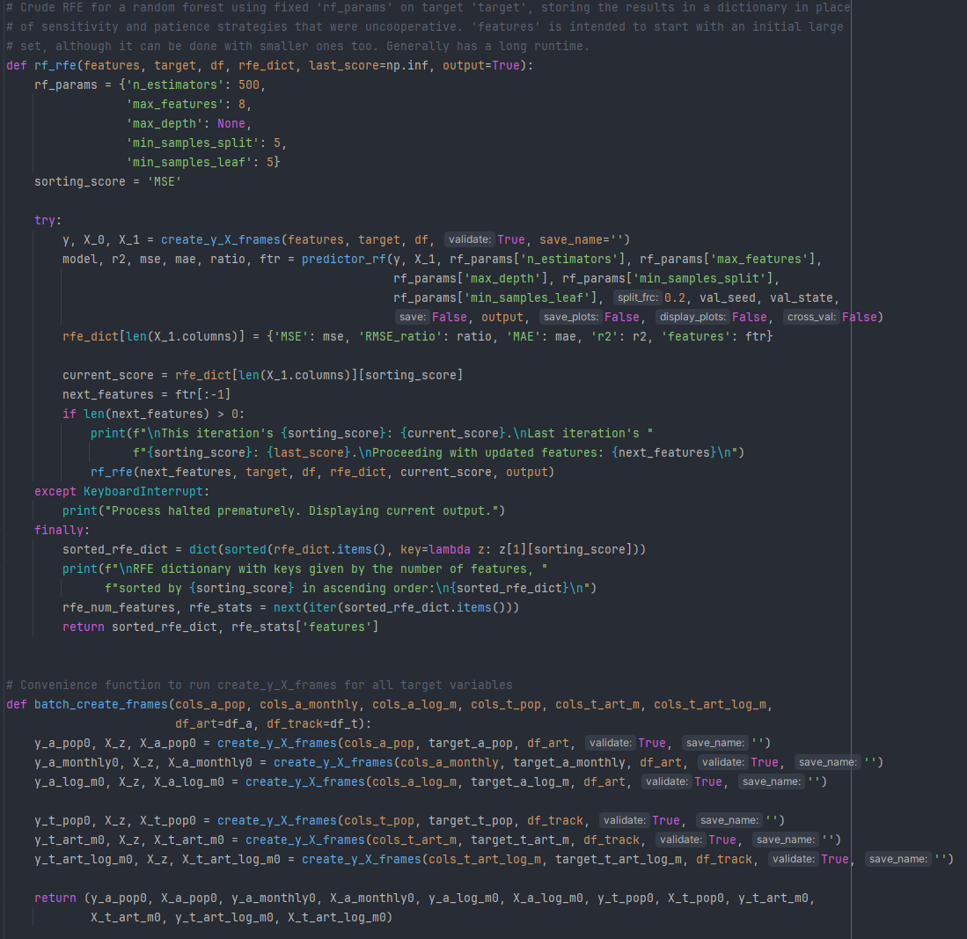

As many different subsets of predictor variables performed well using 500 trees, a maximum of 8 features used at each node split, no prescribed maximum depth, and a minimum value of 5 samples within a leaf node or when splitting, another optimization function, rf_rfe, was used as an approximate recursive feature elimination. The best performing sets of predictors for each target variable were determined in this way (“optimal feature sets”), then passed to hyper_param to refine the random forest parameters and provide the best performing models.

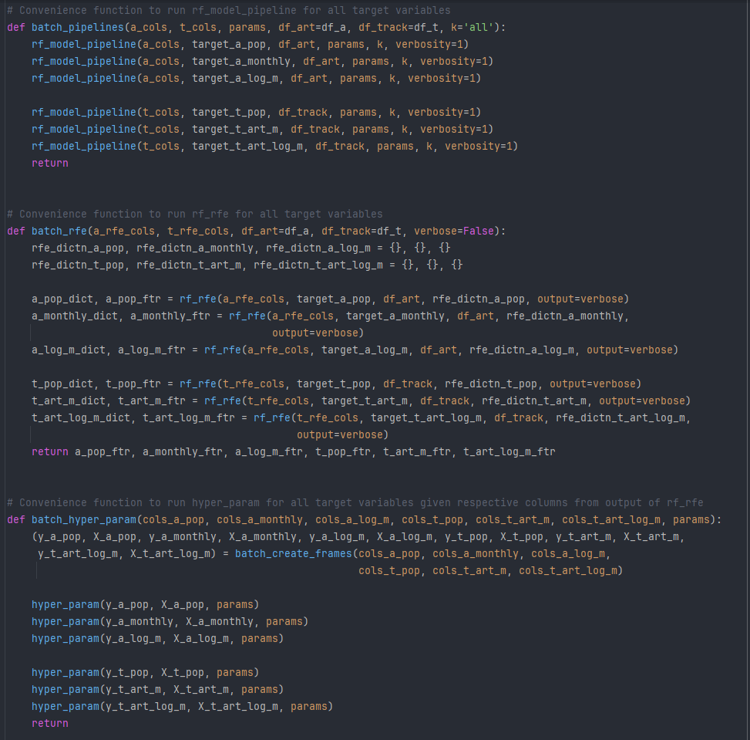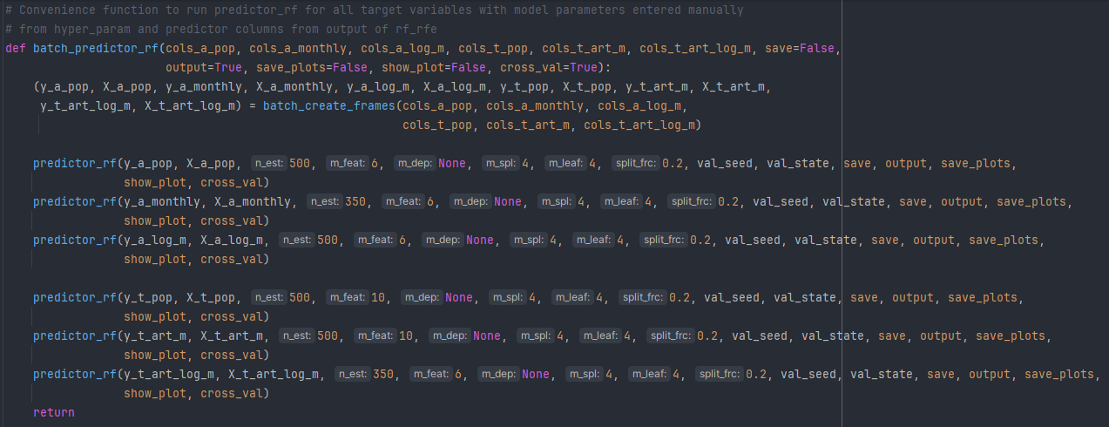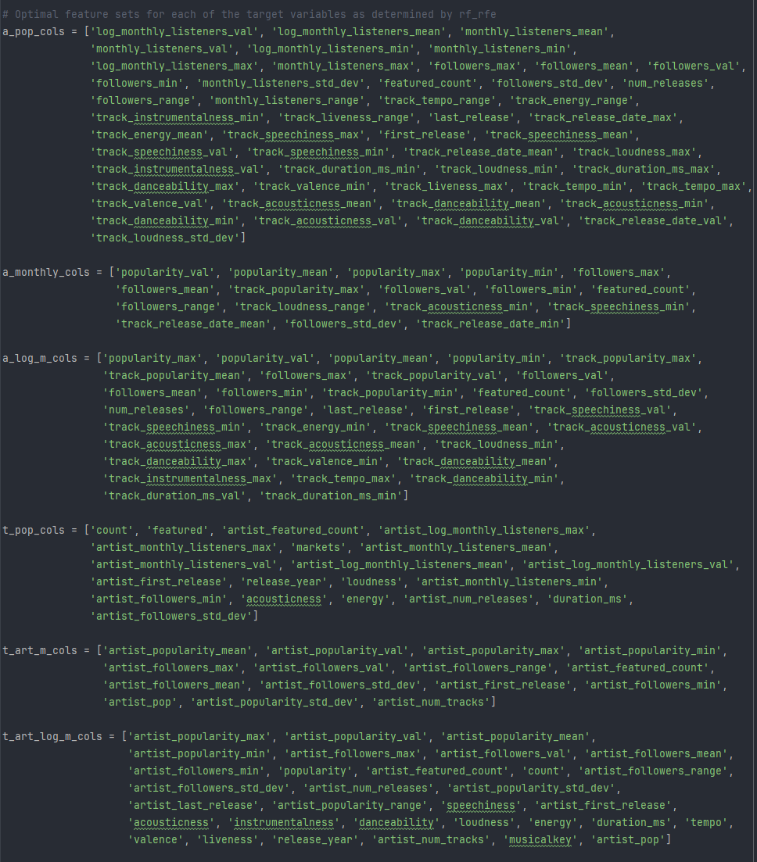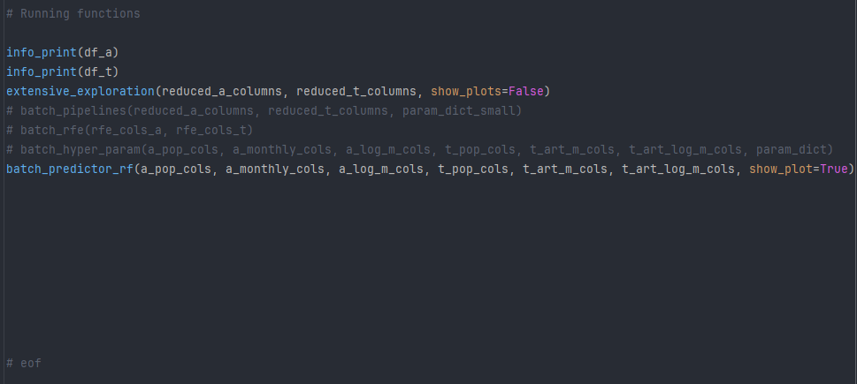

First, both dataframes are verified to have no duplicates or non-critical null values (i.e. null values in ‘dates’ and ‘feat_track_ids’ are expected for artists that only resided in the random sampling and are acceptable):

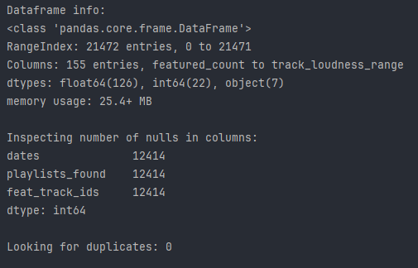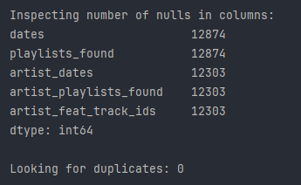

Next, correlations between primarily target variables and potential predictor variables are calculated. To reduce redundant correlations (e.g. ‘popularity_mean’ having a high correlation with ‘popularity_median’), the following correlations ranked in descending order used the reduced sets of columns previously listed on the fourth screenshot of this section (‘reduced_a_columns’ and ‘reduced_t_columns’):

Within the artists dataframe “df_a”, ‘popularity_val’ and ‘monthly_listeners_val’:

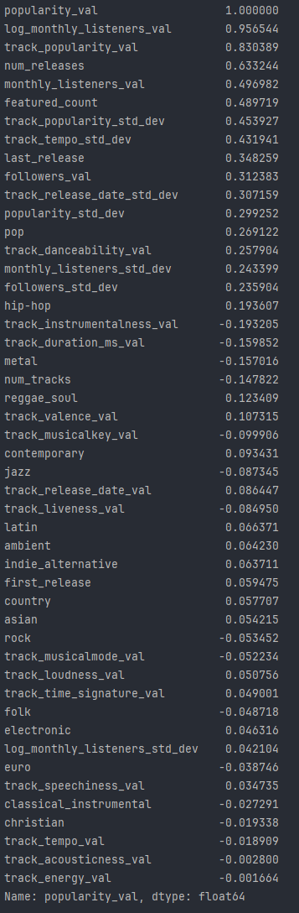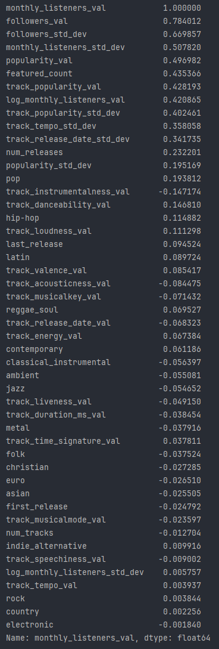

For ‘featured_count’ and ‘log_monthly_listeners_val’:

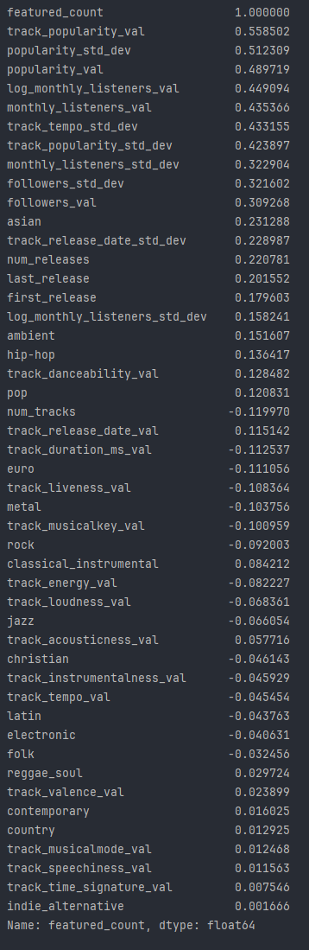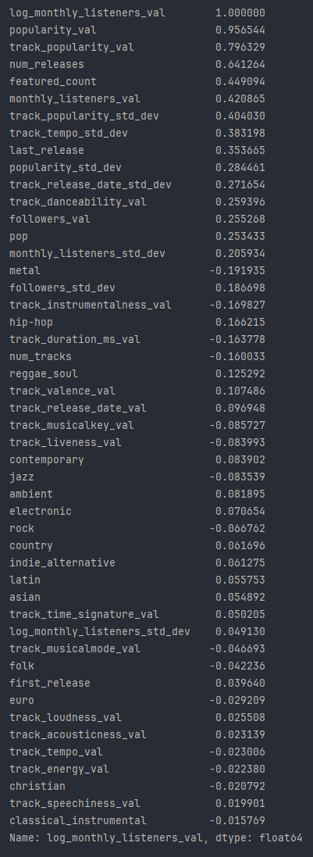

Within the track dataframe “df_t”, ‘popularity’ and ‘artist_monthly_listeners_val’:

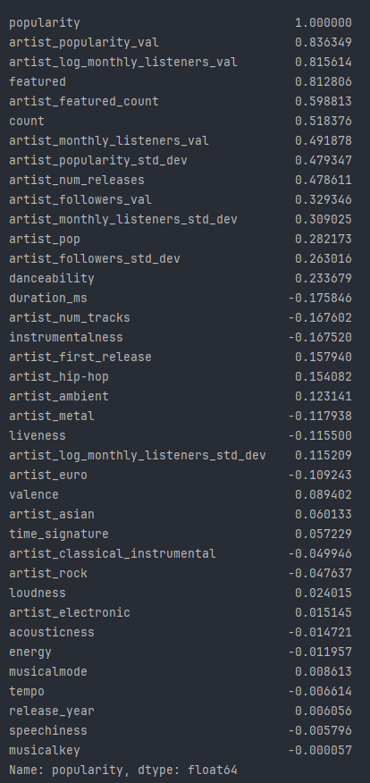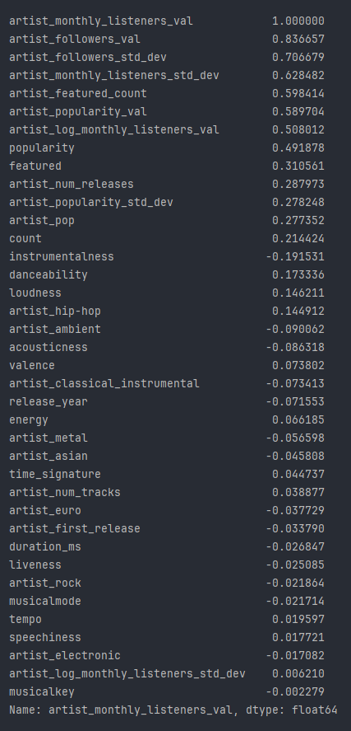

For ‘artist_log_monthly_listeners_val’ and ‘count’:

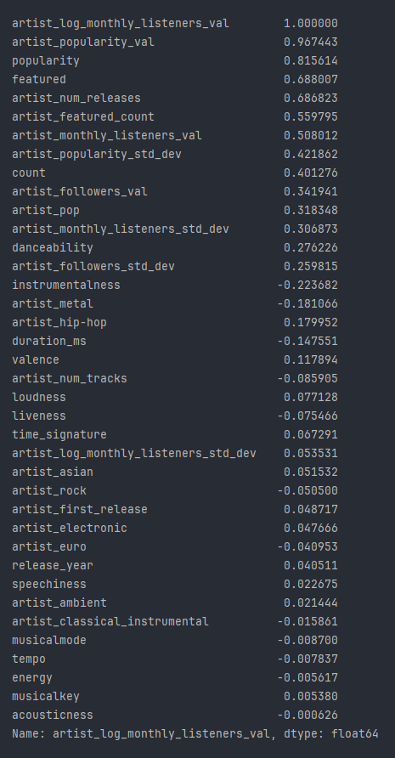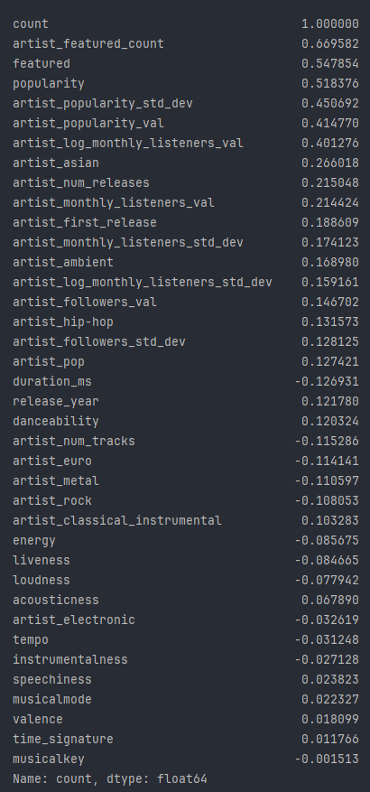

For ‘featured’:

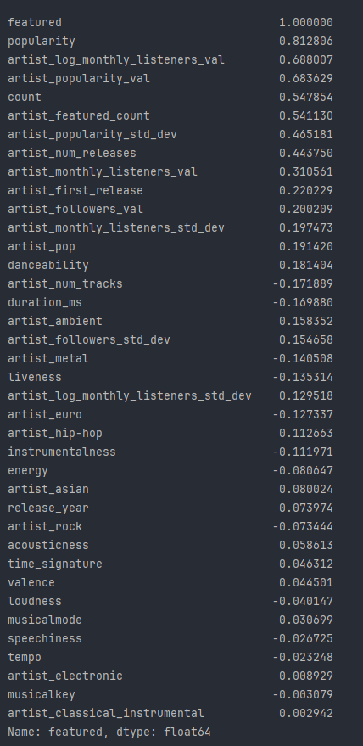

An artist’s median popularity (‘popularity_val’) has a very strong correlation to the median of the base 10 logarithm of their monthly listeners at 0.9565, another strong correlation with the median track popularity at 0.8304, a moderately high correlation of 0.6332 for the number of releases, and other moderate correlations on the number of times they were featured, the standard deviations of their track popularity and track tempo, the number of followers, and the year of their last release.

As might be expected, monthly listeners and followers have strong correlations with one another, at 0.784 with the artist dataframe and 0.837 in the track dataframe, showing a slightly stronger relationship between these variables among the subset of artists who are the selected primary artists of tracks. The artist’s median monthly listeners (‘monthly_listeners_val’) has additional moderately strong correlations with the standard deviation of followers, median popularity, the number of times they were featured, the median popularity of their tracks, the standard deviation of their track popularity, and the standard deviation of their track tempo.

The median of the base 10 logarithm of an artist’s monthly listeners has strong and moderate correlations with median popularity, median track popularity, the number of release, the number of times they were featured, and the standard deviations of their track popularity and track tempo.

Although not a target variable for a model, the number of times an artist is featured (‘featured_count’) has notable correlations with median track popularity, the median and standard deviation of artist popularity, median monthly listeners, and the standard deviations of track tempo and track popularity.

For track popularity, it has strong correlations of 0.8363 with median artist popularity, 0.8156 with the median base 10 logarithm of artist monthly listeners, and 0.8128 with being featured (a binary variable).

The track monthly listener targets ‘artist_monthly_listeners_val’ and ‘artist_log_monthly_listeners_val’ have comparable analogous correlations to the ones previously mentioned for their equivalents within the artists dataframe (i.e. ‘monthly_listeners_val’ and ‘log_monthly_listeners_val’).

These results clearly show statistically significant correlations among candidate predictor variables and each of the six target variables, rejecting the null hypothesis and accepting the alternate hypothesis, indicating statistically significant random forest regression models can potentially be developed from the datasets.

To avoid any risk of circular reasoning within the models, the track popularity values will be excluded from predicting the artist popularity values and vice-versa, which is handled by the function valid_features previously mentioned.

Starting with broad sets of eligible features (see ‘rfe_cols_a’ and ‘rfe_cols_t’ listed in the fifth screenshot of this section (pg. 37) for “df_a” and “df_t” respectively), rf_rfe is used to output results in ascending order of MSE and identify the best selection of features. For ‘popularity_val’, the best performing subset is:

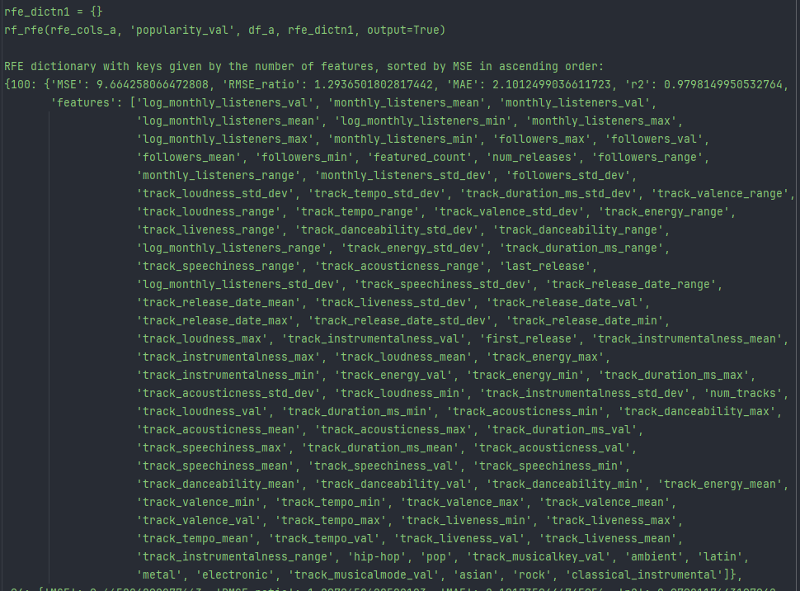

Using 100 features is incredibly unwieldy, so a compromise is made with a small increase in MSE to 9.738 (from 9.664) that only uses 50 features:

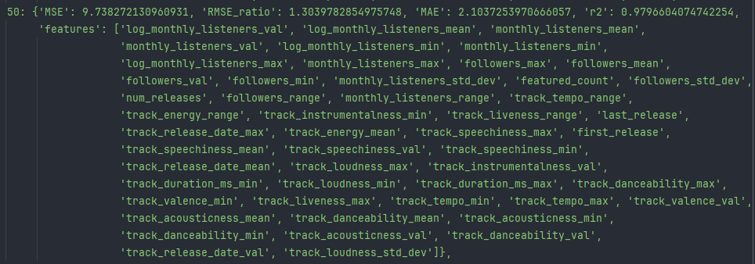

The other target variables provided manageable numbers of features with the minimal MSE. For ‘monthly_listeners_val’:

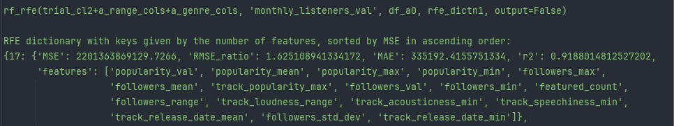

For ‘log_monthly_listeners_val’:

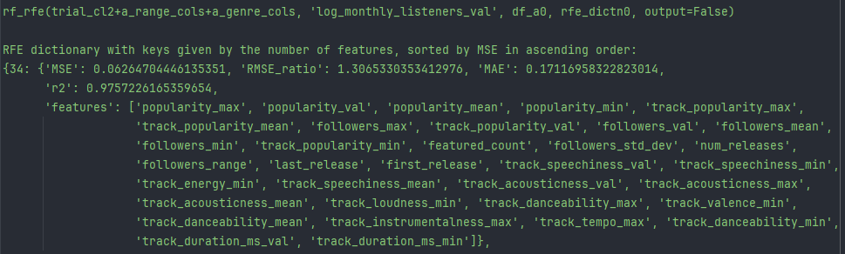

Among the track dataframe, for ‘popularity’, a small error led to the inclusion of three ‘_median’ variables that were removed and after hyperparametric tuning provided a model that performed slightly better. The final set had 20 of the 23 variables listed below after dropping the ‘_median’ containing variables:

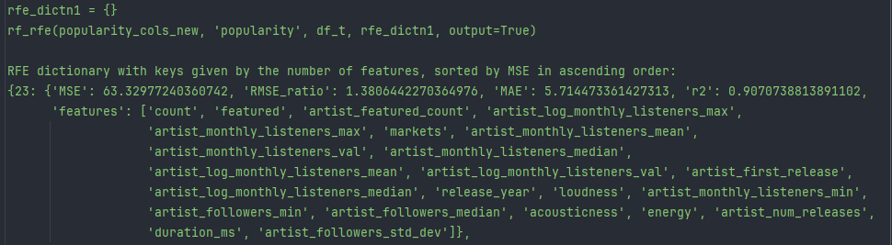

For ‘artist_monthly_listeners_val’:

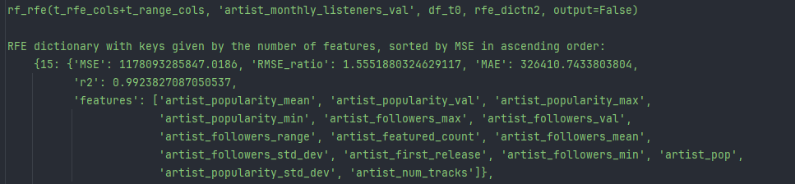

For ‘artist_log_monthly_listeners_val’:

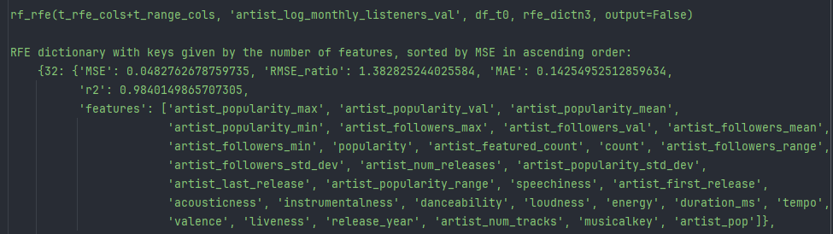

These optimal sets of features were then adapted into the arrays defined on pg. 50 and were passed as input to batch_hyper_param. The optimal parameters found from the grid search are displayed on pg. 49 within the function batch_predictor_rf. Generally, the optimal parameters were 500 estimators (trees), a maximum of 6 features at each node split, no maximum tree depth, a minimum of 4 samples in any node split, and a minimum of 4 samples in a leaf node. Reducing much further than 4 minimum samples (in node splits or leaves) led to indications of overfitting with considerably lower MSE on the training data over the test data.

As a contrast, some comparison models were created to verify the superior performance of the models discussed above.

Predicting ‘monthly_listeners_val’ with all numerical columns in the artist dataframe “df_a” (and similar model parameters as its counterpart model mentioned previously) returns:

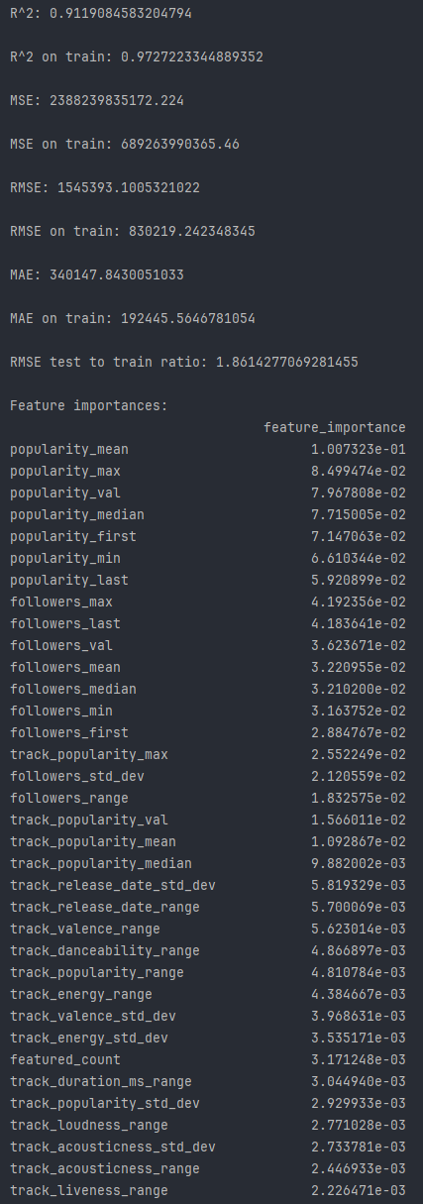

Predicting ‘log_monthly_listeners’ using a limited set of features restricted to the genre variables, variables ending in ‘_val’ (i.e. only the median (or mode where relevant) with no inclusion of maxima, minima, etc.), 'featured_count', 'first_release', 'last_release', 'num_releases', and 'num_tracks':

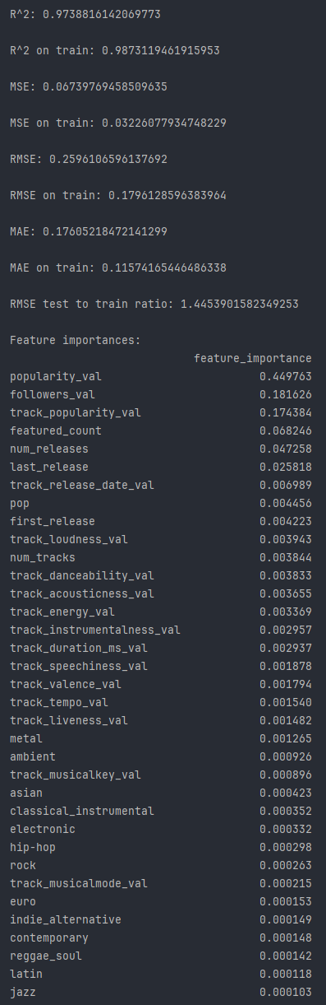

Predicting track ‘popularity’ with all numerical columns in the track dataframe “df_t”:

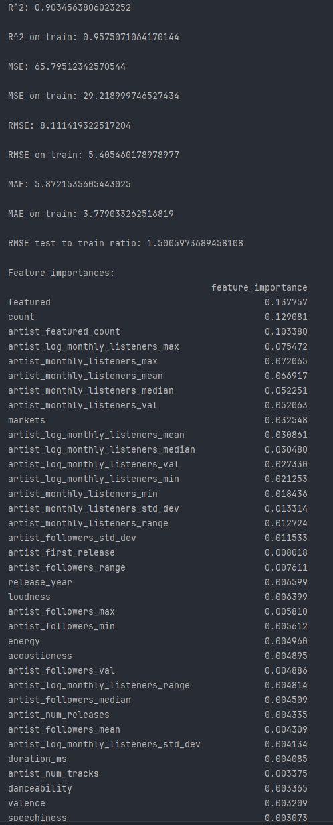

Predicting ‘artist_monthly_listeners_val’ within the track dataframe “df_t” using a limited set of features restricted to the artist’s genre variables, the artist’s median continuous values (i.e. popularity, followers, monthly listeners, and the base 10 logarithm of monthly listeners), 'featured', 'popularity', 'markets', 'duration_ms', 'acousticness', 'danceability', 'energy', 'instrumentalness', 'liveness', 'loudness', 'speechiness', 'tempo', 'valence', 'musicalkey', 'musicalmode', 'time_signature', 'count', 'release_year', 'artist_featured_count', 'artist_first_release', 'artist_last_release', 'artist_num_releases', and 'artist_num_tracks':

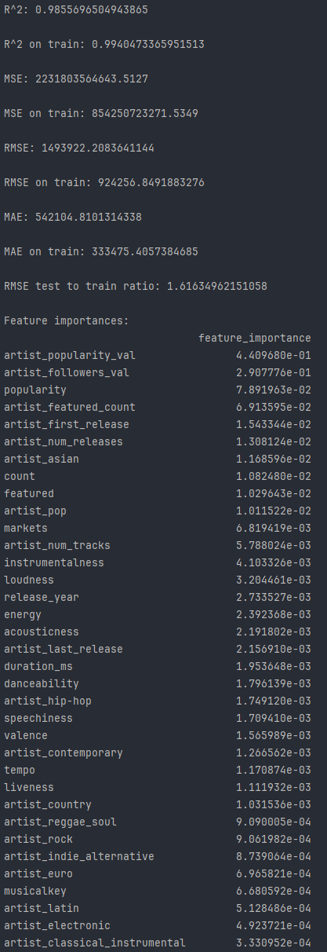

Moving to the final models selected by rf_rfe and hyper_param and their associated residual and QQ plots:

‘popularity_val’ from the artist dataframe “df_a”:

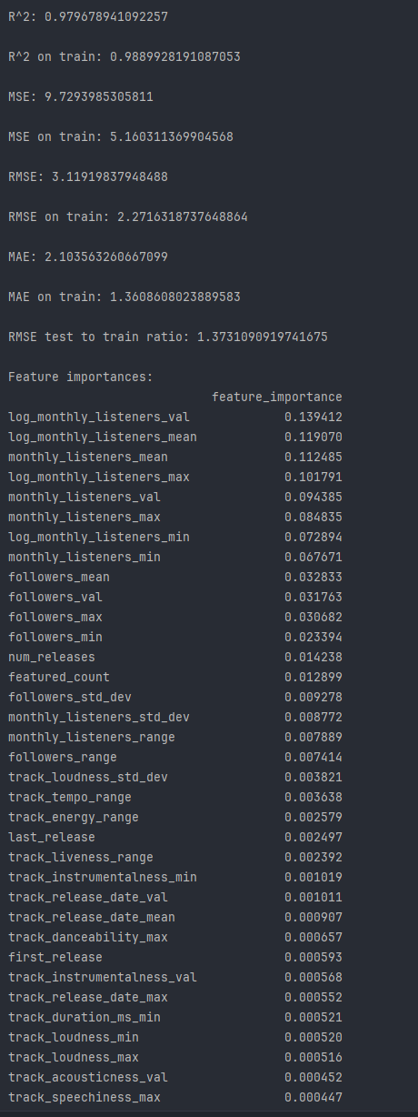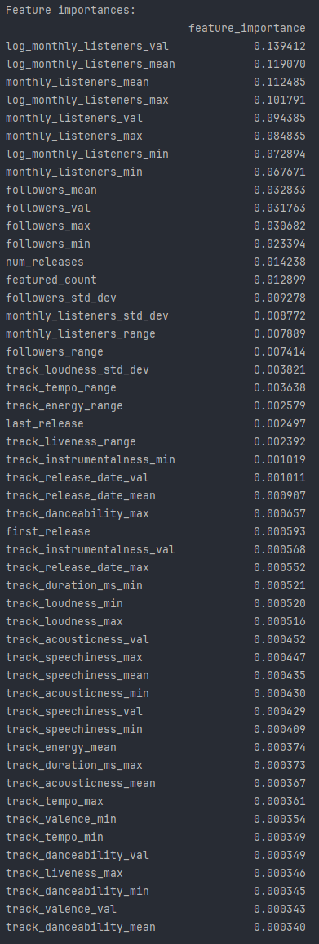



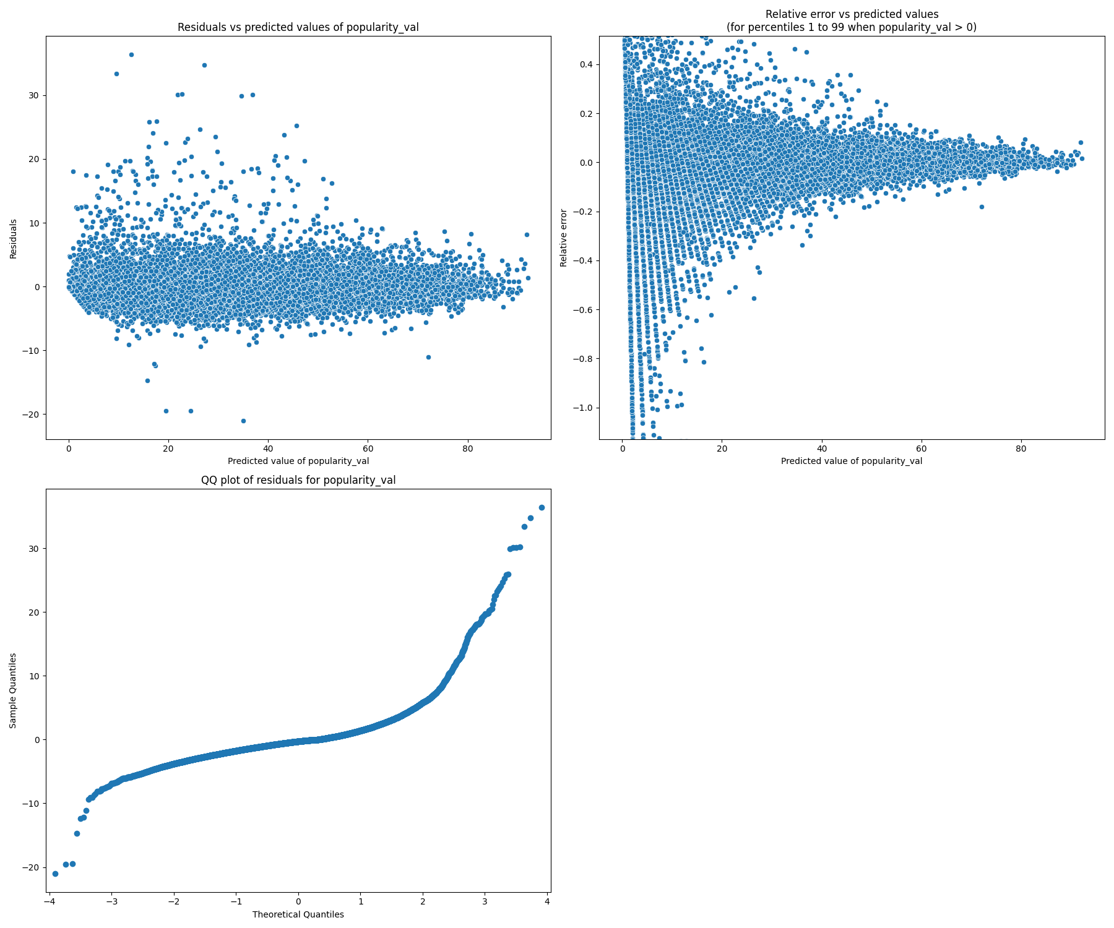

‘monthly_listeners_val’ from the artist dataframe “df_a”:

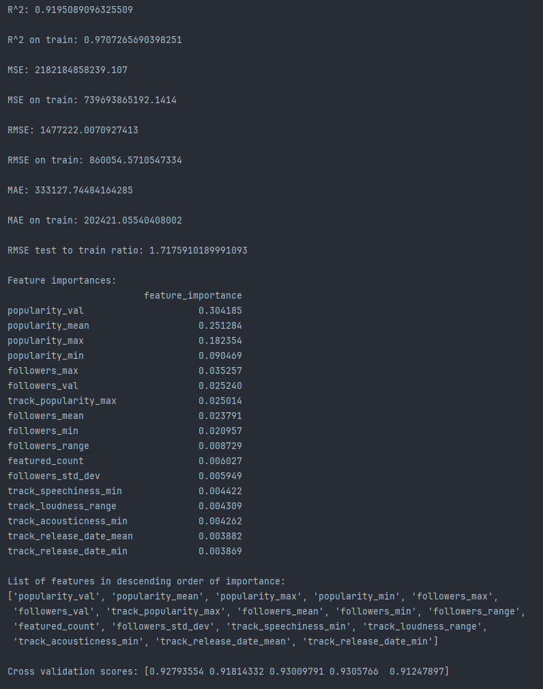

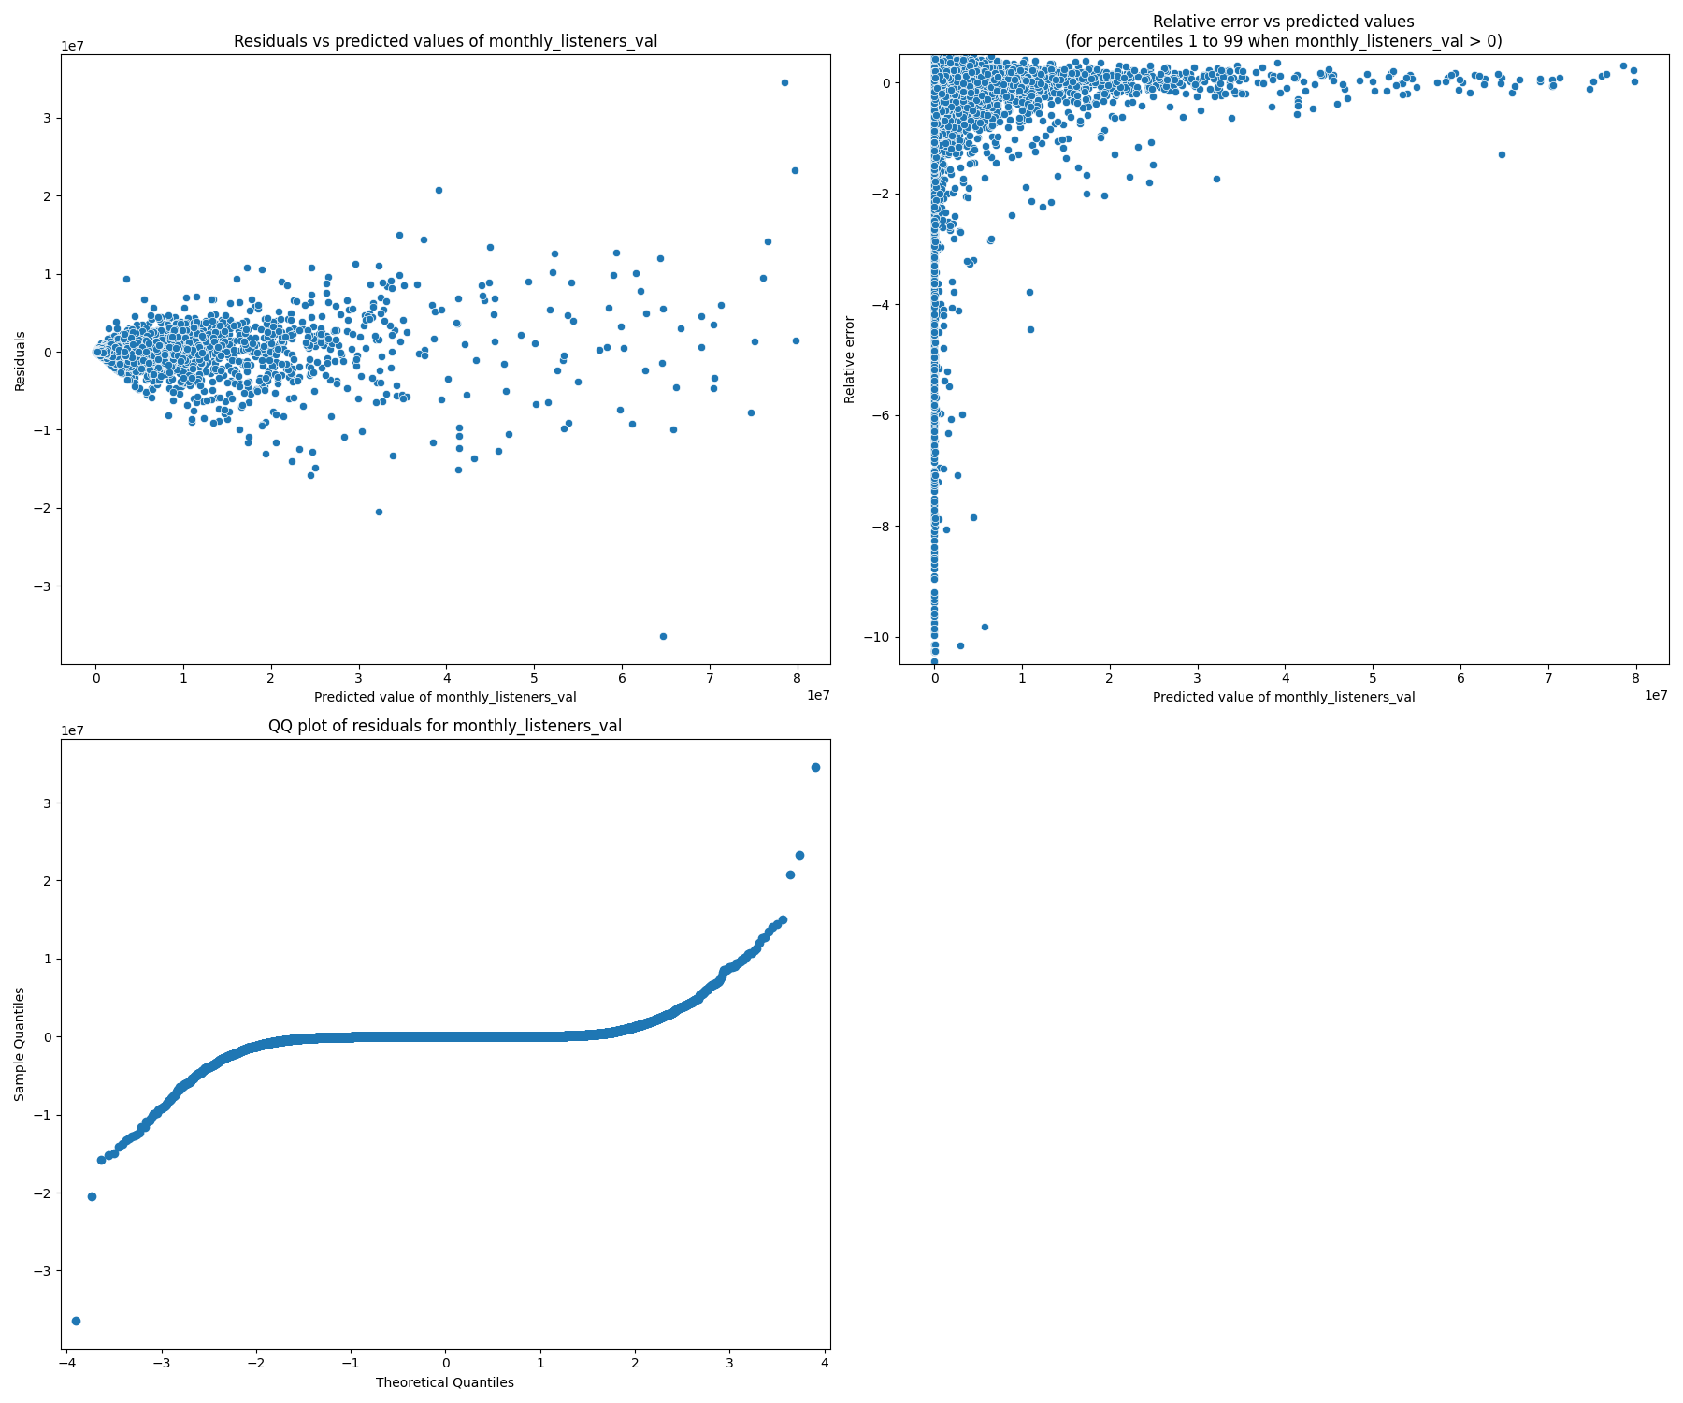

‘log_monthly_listeners_val’ from the artist dataframe “df_a”:

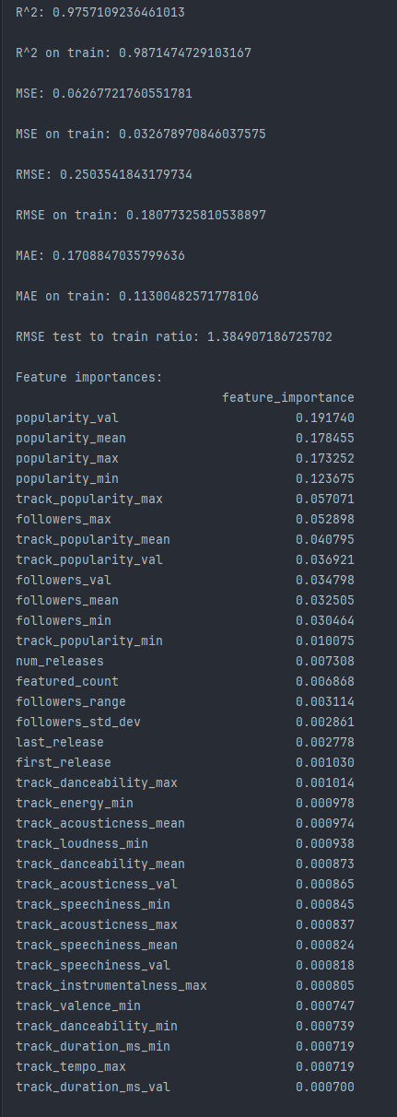



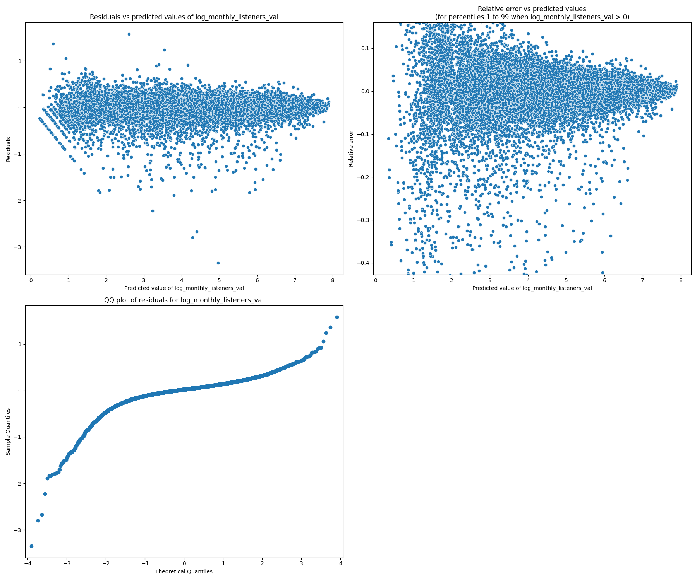

‘popularity’ from the track dataframe “df_t”:

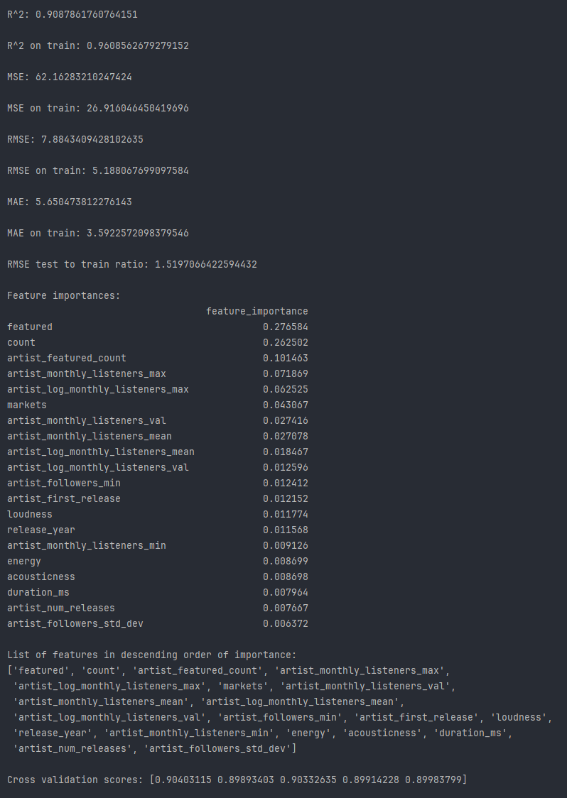

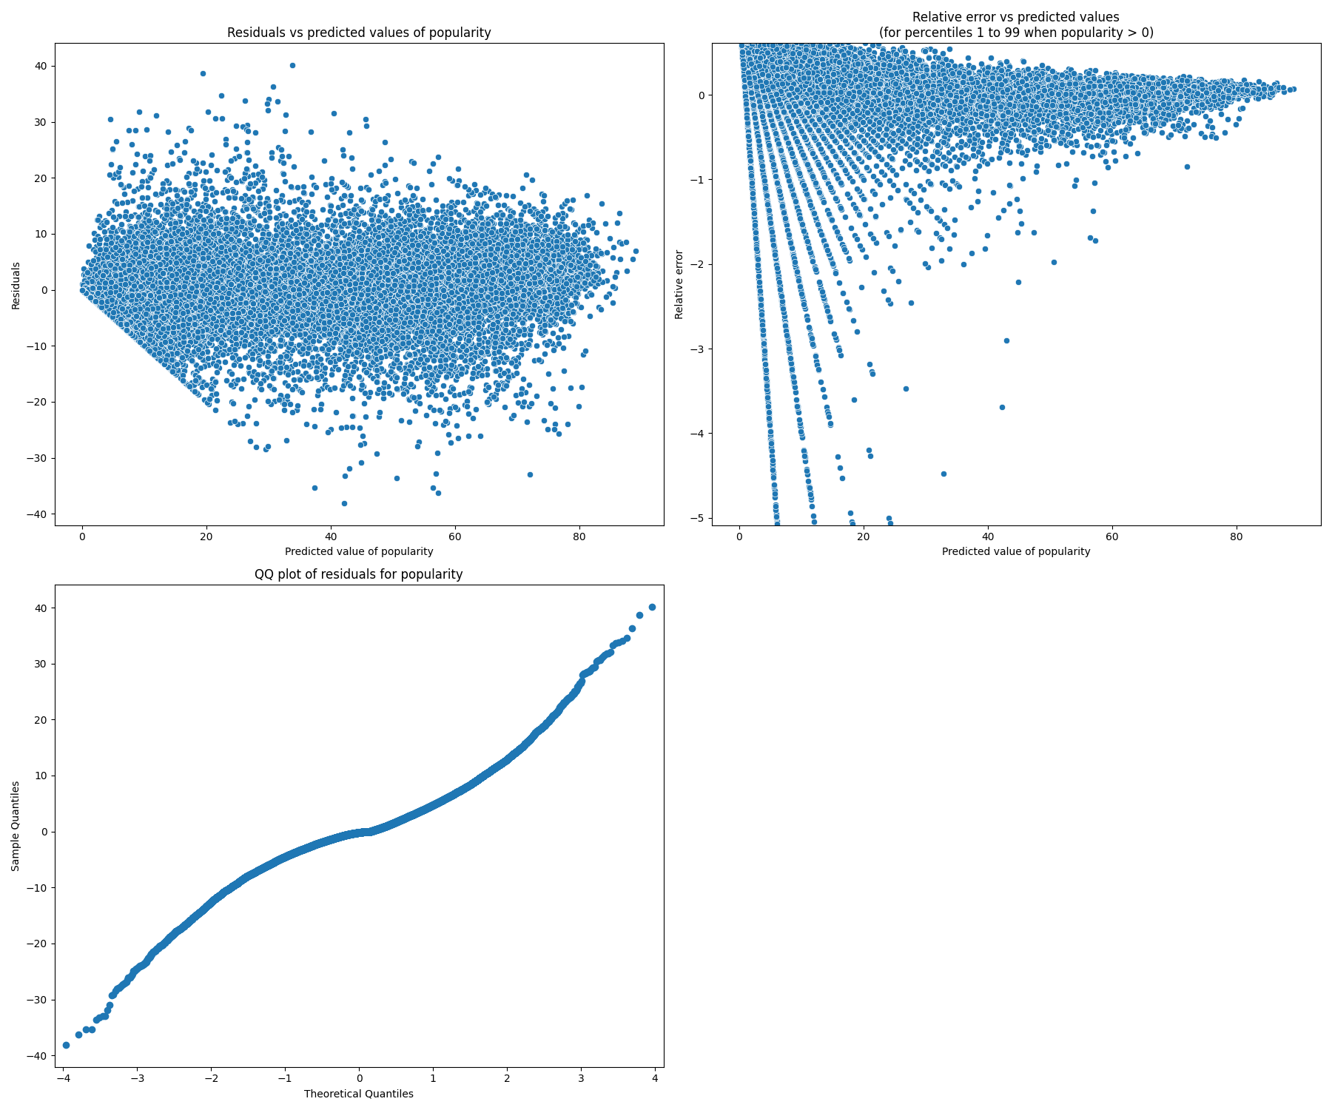

‘artist_monthly_listeners_val’ from the track dataframe “df_t”:

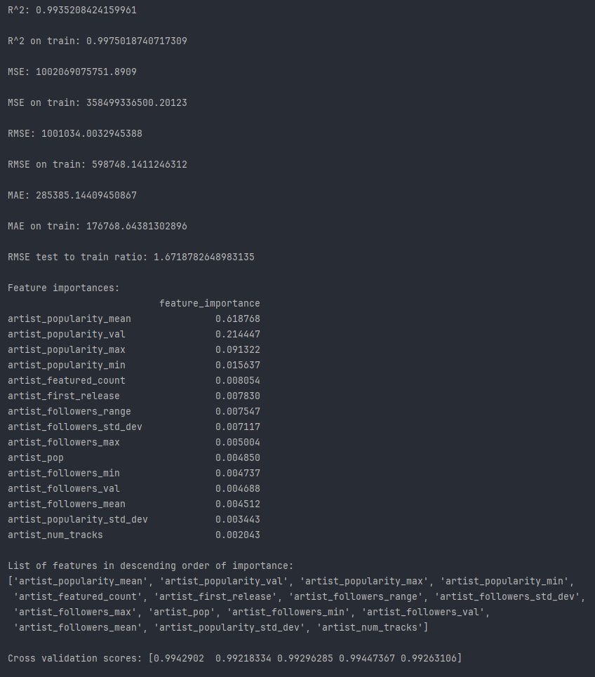

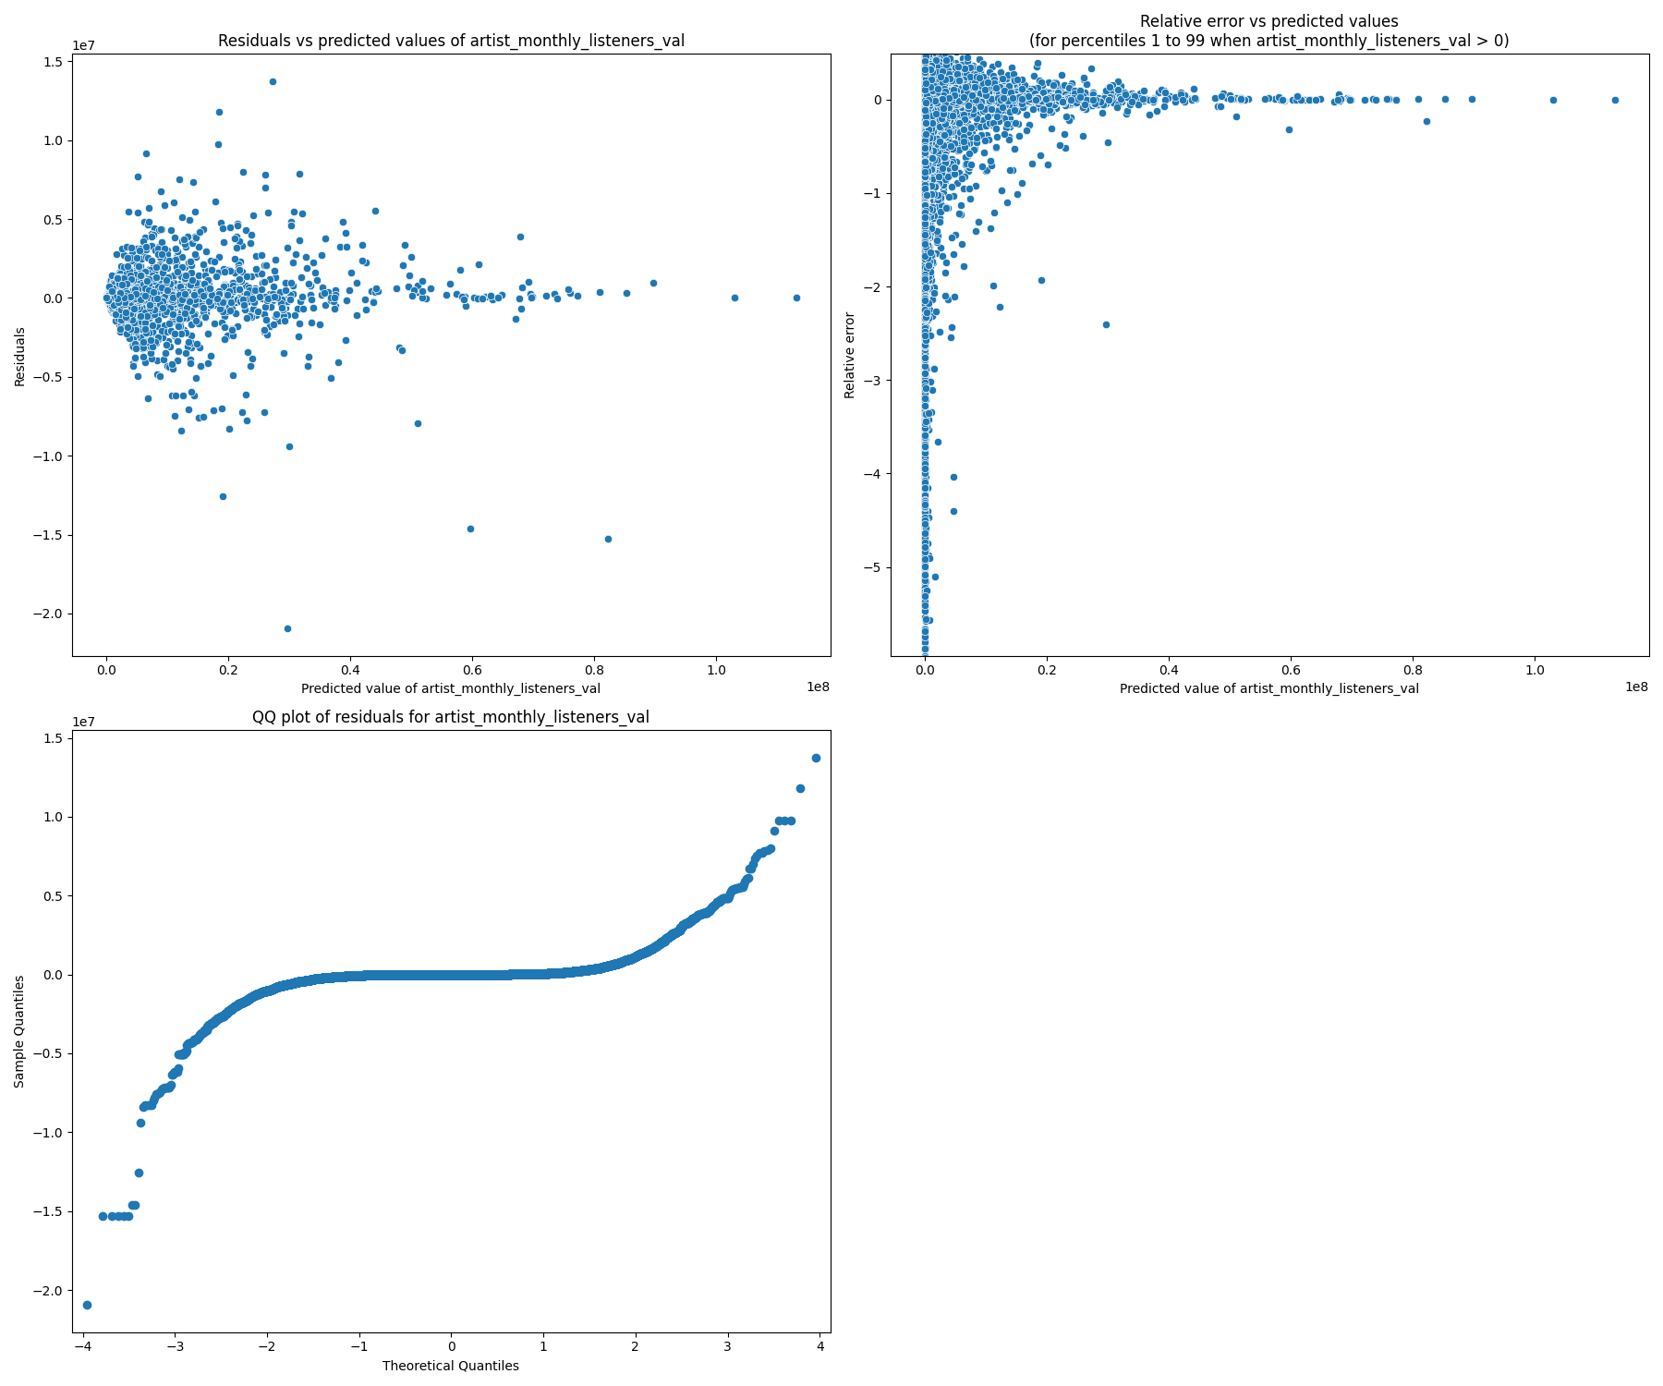

‘artist_log_monthly_listeners_val’ from the track dataframe “df_t”:

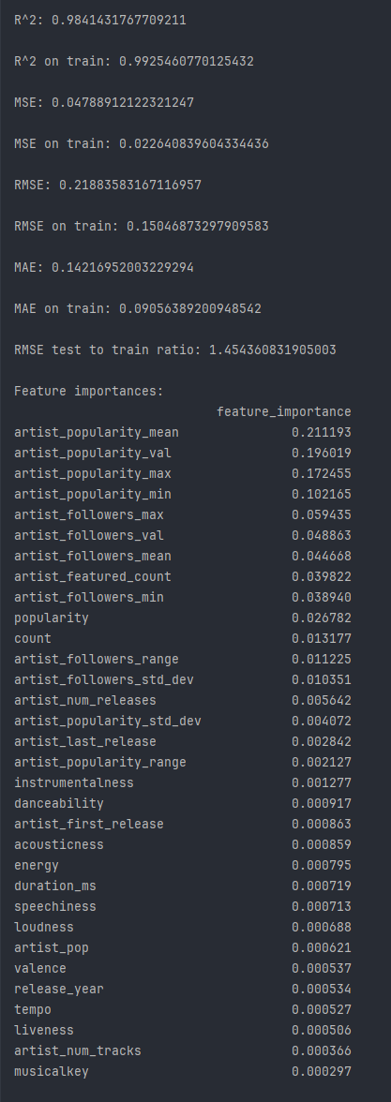

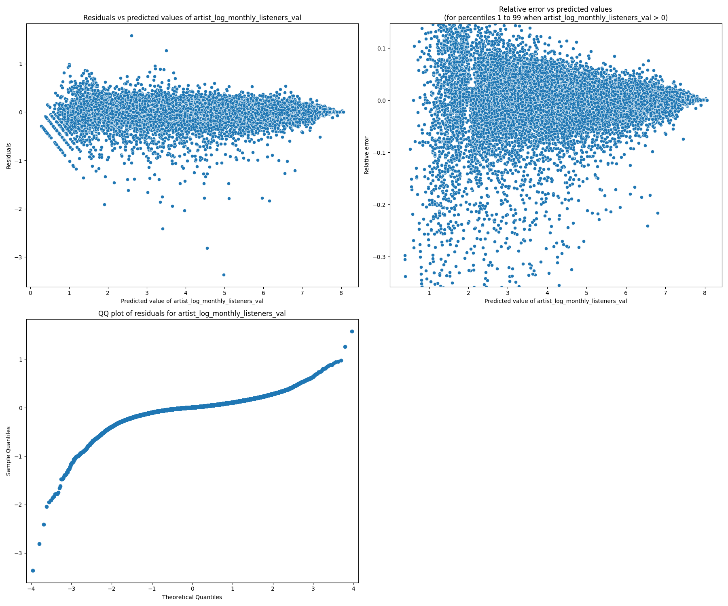

Note that the relative error plots divide the residuals by the observed values among the observed values that are greater than 0. Additionally, extreme outliers made the plots of little visual use, so the vertical axis (for relative error) was limited to the 1st and 99th percentiles among the relative error distribution.

Returning to the comparison model outputs starting on pg. 62, predicting ‘monthly_listeners_val’ using all numerical features in “df_a” had:

$R^{2}$ = 0.912, MSE = 2.388 * 1012, RMSE = 1.545 * 106, MAE = 3.401 * 105

The final model for ‘monthly_listeners_val’ had the superior values of:

$R^{2}$ = 0.920, MSE = 2.182 * 1012, RMSE = 1.477 * 106, MAE = 3.331 * 105

For predicting ‘log_monthly_listeners_val’ with a limited set of features, the model had:

$R^{2}$ = 0.974, MSE = 0.0674, RMSE = 0.260, MAE = 0.176

The final model for ‘log_monthly_listeners_val’ had the better values of:

$R^{2}$ = 0.976, MSE = 0.0627, RMSE = 0.250, MAE = 0.171

For predicting ‘popularity’ with all numerical features in “df_t”:

$R^{2}$ = 0.904, MSE = 65.795, RMSE = 8.111, MAE = 5.872

The final model for ‘popularity’ had the preferred values of:

$R^{2}$ = 0.909, MSE = 62.163, RMSE = 7.884, MAE = 5.651

For predicting ‘artist_monthly_listeners_val’ with a limited set of features, the model had:

$R^{2}$ = 0.986, MSE = 2.231 * 1012, RMSE = 1.494 * 106, MAE = 5.421 * 105

The final model for ‘artist_monthly_listeners_val’ had the improved values of:

$R^{2}$ = 0.994, MSE = 1.002 * 1012, RMSE = 1.001 * 106, MAE = 2.854 * 105

Generally, the improvements are relatively minor but not inconsequential, the exception of ‘artist_monthly_listeners_val’ which upon examining the features used in the final model reveals the importance of multiple statistical variables connected to ‘artist_popularity’ and ‘artist_followers’.

The final models generally performed well and have reasonable residual plots. The targets never go below 0, so a boundary line is visible in the residuals, especially in ‘popularity’. Apart from the boundary line, the residual plots for ‘popularity’, ‘popularity_val’, ‘log_monthly_listeners_val’, and ‘artist_log_monthly_listeners_val’ are fairly uniformly distributed about 0, although the QQ plots demonstrate some skewness with outliers on the extremes. This is largely expected given the skewed distributions, such as the great number of artists with very low popularity values and vastly different monthly listener counts between the worst and best performing artists. The residuals for ‘monthly_listeners_val’ and ‘artist_monthly_listeners_val’ show a larger cluster concentrated at the smaller values. Without the logarithmic adjustment, the few outlying artists on the linear horizontal scale are an expected result. The cluster is reasonably uniform within its restricted domain of artists who don’t have extraordinarily high monthly listener counts. Similarly, the QQ plots show skewness with the outliers.

**E. Data Summary and Implications**

As laid out in section A., the project’s hypothesis testing used the following hypotheses:

Null hypothesis: There are no statistically significant relationships between the target variable popularity and potential predictor variables artist followers, genres, number of releases, song duration, and tempo.

Alternate Hypothesis: There are statistically significant relationships between popularity and one or more of artist followers, genres, number of releases, song duration, and tempo.

From the calculations of correlation coefficients with the six target variables and the discussion on pg. 58, the null hypothesis is rejected and the alternate hypothesis is accepted.

To summarize the results of the random forest regression models:

For the model predicting an artist's median popularity ('popularity_val' from "df_a"):

$R^{2}$ = 0.980, MSE = 9.729, RMSE = 3.119, MAE = 2.104

For the model predicting an artist's median monthly listeners ('monthly_listeners_val' from "df_a"):

$R^{2}$ = 0.920, MSE = 2.182 * 1012, RMSE = 1.477 * 106, MAE = 3.331 * 105

For the model predicting an artist's median base 10 logarithm of monthly listeners ('log_monthly_listeners_val' from "df_a"):

$R^{2}$ = 0.976, MSE = 0.0627, RMSE = 0.250, MAE = 0.171

For the model predicting a track's popularity ('popularity' from "df_t"):

$R^{2}$ = 0.909, MSE = 62.163, RMSE = 7.884, MAE = 5.651

For the model predicting a track's associated primary artist's median monthly listeners ('artist_monthly_listeners_val' from "df_t"):

$R^{2}$ = 0.994, MSE = 1.002 * 1012, RMSE = 1.001 * 106, MAE = 2.854 * 105

For the model predicting a track's associated primary artist's median base 10 logarithm of monthly listeners ('artist_log_monthly_listeners_val' from "df_t"):

$R^{2}$ = 0.984, MSE = 0.0479, RMSE = 0.219, MAE = 0.142

Notably the base 10 logarithm of monthly listeners has far more practically navigable errors, as 10MAE ~ 1.39 is handled more readily than ~3*105 when many artists have monthly listeners well below that value. The lower $R^{2}$ values for ‘popularity’ and ‘monthly_listeners_val’ show some weakness in those predictions relative to the others. An RMSE of 3.119 for popularity values ranging from 0 to 100 is very promising. In contrast, the track popularity prediction RMSE is notably higher at 7.884. The RMSE for 'artist_monthly_listeners_val' (from “df_t”) is nearly two thirds of the analogue ‘monthly_listeners_val’ (from “df_a”). This may arise from a primary artist selection bias restricting to an (unknown) cluster with more homogeneous adherence to underlying dynamics more accurately captured by the random forest.

The research question stated in section A. sought to find the relevance of the features within the datasets in predicting the popularity of an artist or track (song) and an artist’s monthly listeners. The most relevant features as determined by feature importance scores are overwhelmingly the (valid to the target variable) different statistical values (e.g. ‘_mean’ and ‘_max’) pertaining to monthly listeners, followers, popularity, and ‘featured_count’ (including its analogues ‘featured’ and ‘count’) for all six of the target variables. The comparison models with limited sets of features demonstrate that although reasonable models can still be constructed with less detailed statistical information on these key variables, the substitutes taking their place still have relatively low feature importance scores. For instance, when predicting ‘artist_monthly_listeners_val’ within the track dataframe “df_t” (see pg. 65), the most important variable not fitting one of the above descriptions is ‘artist_first_release’ with a feature importance of 0.0154. For predicting ‘log_monthly_listeners’ with a limited set of features (pg. 63), the most important feature not fitting one of the four variable categories mentioned is ‘num_releases’ with a feature importance of 0.0473. The correlations previously discussed make it clear that there are non-trivial relationships to the target variables of interest outside of followers, monthly listeners, popularity, and the number of times an artist or song is featured, although they remain the most dominant influences when predicting one of the six target variables. Random forests split on thresholds and are thus relatively insensitive to vast scale differences, so the stark difference in relevance cannot be attributed to the broad scales present with monthly listener and follower counts. That said, although their feature importances were relatively small, ‘markets’, ‘first_release’, ‘num_releases’, and ‘last_release’ ranked higher than others outside of the primary four.

Adequate models can be constructed with a limited set of variables for most targets such as only a median or mean value (a notable exception being ‘artist_monthly_listeners_val’), yet they can be improved with increased statistical granularity. Mean, median, maximum, and minimum values tend to be the most commonly occurring given the feature sets determined by rf_rfe, although standard deviations and ranges (difference of maximum and minimum) also occur.

The analysis is limited by the relatively short timeframe in which the data was collected and the many artists who have very small audiences and may no longer be active. A longer timeframe would give the models more robustness to any unknown seasonal impacts or broad changing trends in audience interests. Inactive artists and those with very small audiences likely have very different dynamics than the most popular artists, such as a small likelihood of ever being featured in a playlist. These differing underlying dynamics, should they exist, aren’t necessarily captured by the decision tree ensembles without some type of clustering and applying different models to different regimes. The implementation of scanning genres for keywords and using one-hot encoding did not find many significant relationships. Genres were largely irrelevant and frequently some of the first features dropped during recursive feature elimination. They very well may lack impact in a song or artist’s popularity and monthly listeners, although the number of artists with missing and potentially inaccurate genres is concerning. Nonetheless, ‘pop’, ‘ambient’, and ‘hip-hop’ did have small to moderate correlation values, with ‘pop’ having a small feature importance in a few of the final models. Additionally, there was no way to determine if followers were inactive or monthly listener counts were in part due to bot traffic.

As Spotify assuredly has teams of dedicated engineers and data scientists analyzing and modeling their data and modifying their algorithms, the results of this project were primarily aimed at being of informative use to artists and listeners interested in knowing what makes a popular song or artist. For artists, their popularity and monthly listeners are driven chiefly by popularity, followers, monthly listeners, and being featured frequently. They may find themselves in a chicken and egg catch-22 where it’s extremely difficult to build momentum. Although not causative by any means, as popular artists who favor a certain tempo or genre with a dedicated audience could mislead other artists into thinking there’s something inherently popular about that tempo or genre, artists looking to build their popularity might try to mimic some of these more popular aspects in the hopes of being featured. Ambient, hip-hop, and pop, as previously mentioned, appear to be the more popular and better performing genres, whereas metal has a negative correlation with monthly listeners and popularity. Higher numbers of releases correlating with higher popularity is likely survivor bias where established artists continue producing, although without knowing how Spotify’s algorithms work, it’s possible that someone with frequent releases is more likely to be recommended to prospective listeners more frequently, similar to YouTube and other media platforms. Additionally, loudness, danceability, and the standard deviation of tempo have positive correlations that may have a currently undetermined causal influence on track popularity among listeners. Reviewing scatter plots, danceability appears to have a peak value of ~0.65 for artists with the highest number of monthly listeners. Again, causality cannot be determined from this project, but it could offer some possibilities for newer artists to explore.

Future analysis with this data, potentially augmented with additional data collection, might look into clustering different artists, markets, or (anonymized) listening profiles. The results of these current models are best suited to Spotify in general and are not necessarily very helpful to artists and listeners within specific niches. Certain correlations may be more or less meaningful within certain clusters but are obscured (or magnified) in the bulk of the data. Building separate models for separate clusters (or supplementary child models added to a primary parent model) could provide better results and insights.

With additional data collection, temporal analysis could be performed studying the impact on an artist’s popularity, followers, and monthly listeners after being featured in the previous day, week, or relevant time period. The time period of data collection in this project was too brief to perform any meaningful time series analysis. Observing granular changes in an artist’s traffic after being featured could give a more precise quantitative interpretation to the impact of featuring an artist.

Additional analysis could further benefit from accessing how many times a track is listened to in a month or in total, but as of the present day that quantity isn’t available through the API and scraping it from the artist’s or track’s Spotify pages is forbidden by Spotify’s access terms. The impact of Spotify suggestions on what listeners select would also offer insights into audience listening habits, but similarly is undisclosed proprietary information. Should that change at some point in the future, further analysis could work with those details to better understand the dynamics of popular artists, tracks, and audience habits.

**F. Sources**

**1.** Jeffreson, Sarah. 2024. Featured Spotify artists/tracks with metadata. Retrieved June 3, 2024 from <https://www.kaggle.com/datasets/sarahjeffreson/featured-spotify-artiststracks-with-metadata>

**2.** Jeffreson, Sarah. 2024. Large random Spotify artist sample with metadata. Retrieved June 3, 2024 from

<https://www.kaggle.com/datasets/sarahjeffreson/large-random-spotify-artist-sample-with-metadata>

**3.** Spotify. 2024. Web API Reference | Spotify for Developers “Get Track”. Retrieved June 3, 2024 from <https://developer.spotify.com/documentation/web-api/reference/get-track>

**4.** Spotify. 2024. Web API | Spotify for Developers. Retrieved July 12, 2024 from https://developer.spotify.com/documentation/web-api

**5.** Jeffreson, Sarah. 2024. GitHub – sjeffreson/search: Data collection and scraping. Retrieved July 12, 2024 from <https://github.com/sjeffreson/serch>

**6.** Spotify. 2024. Web API Reference | Spotify for Developers “Get Track’s Audio Features”. Retrieved July 12, 2024 from <https://developer.spotify.com/documentation/web-api/reference/get-audio-features>

**7.** Elleh, Festus. 2023. WGU “D209 Data Mining 1 Task 2 Cohort.pptx”. Retrieved July 13, 2024 from https://westerngovernorsuniversity.sharepoint.com/:p:/r/sites/DataScienceTeam/_layouts/15/Doc.aspx?sourcedoc=%7B4B73AB47-67CB-4E1F-ABF9-33FAB2B3E26F%7D&file=D209%20Data%20Mining%201%20Task%202%20Cohort.pptx&action=edit&mobileredirect=true